

Screen Recording
on the Raspberry Pi
Date Created June 2021
Reviewed
Version

Description
Basic setup for screen recordings

Typographic Conventions
Style | Description | Example
Text Body  Liberation Serif 10 | Normal body text | This is normal text
Key (Light Teal 4) | Keyboard shortcut | Press Ctrl + c to copy object
sudo su | Commands that should be run by theuser | sudo apt update
menu | Menu Item | File > save to acess the save feature

Table of Contents
Typographic Conventions 2
Introduction 3
Installations 4
SimpleScreenRecorder 4
Audacity 7
OpenShot video editor 8

Introduction
Screen recording can be a bit of a nightmare if you’re not very techie!
I hope these notes will turn this into a dream!

I tried most of the recommended software and was very disappointed with the results, almost everything caused problems. Even software that was supposed to run out of the box had issues.
So to save you the heartache I had here’s my tips.
Don’t go for software like OBS Studio, it is good but it’s not easy to use or install. Instead go for something more simple and user friendly.
I guess a good thing to point out here, as it is the cause of many issues is that the micro-processor in the Raspberry Pi is not from the same family as found in most PCs and Laptops.
The Pi uses ARM microprocessors while most PCs and Laptops use AMD.
So after much messing about I settled for SimpleScreenRecorder for making the actual screen recordings, Audacity for the audio work, OpenShot video editor for the video editing and VLC for playing back the recordings.
Of these only VLC is installed on the Pi so you have to do some work.
I have been very happy with the results.
Note: When using SimpleScreenRecorder I used the ALSA Backend not PulseAudio.

Installations
Before installing anything on my Pi I always make sure everything id up to date using
sudo apt update
followed by:
sudo apt upgrade
That done you can continue with the installation of the packages

SimpleScreenRecorder
The easiest screen recorder I have found which does all the basics
sudo apt install simplescreenrecorder

Once installed you are presented with a series of screens. If you want to record the desktop then there is no need to change anything here. Of course you can always experiment. If you do decide to change things then it is best to change only one thing at a time!
First Screen
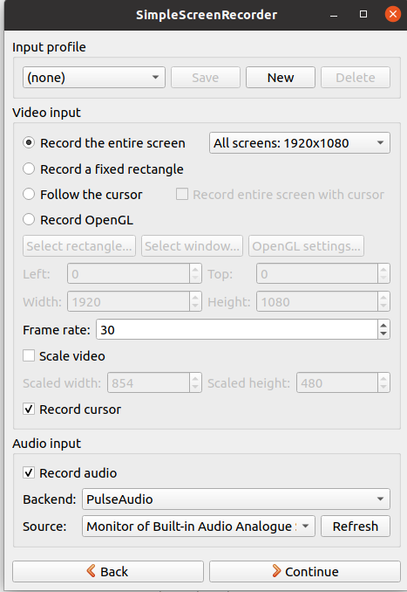
One thing to note on this screen is the Audio input. The back-end is PulseAudio and I have had issues with this so I tend to use the alternative ALSA option. This change will be done on another screen.
Second Screen
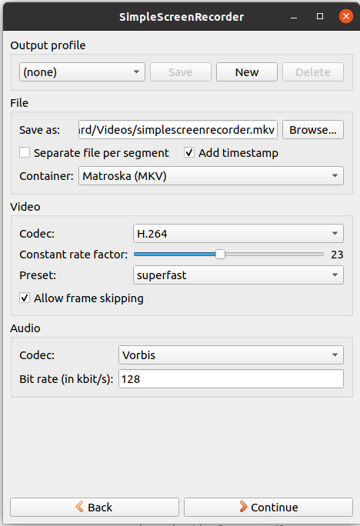
Saved file location and name
Useful to add a time stamp
I change this to MP4 which is more universal
I change this to MP3
Screen 4
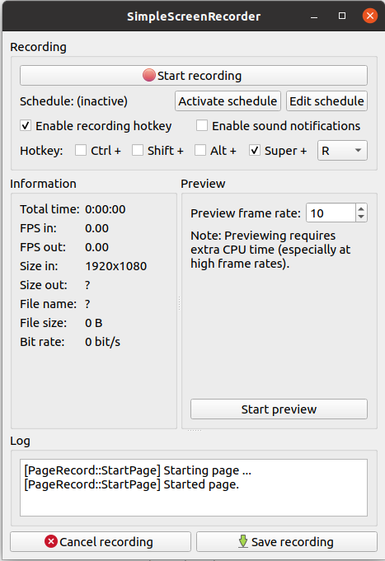
Ready to start recording
Click here to start recording
Click here to save recording and save it

Audacity
This is the best audio editor I have used.
sudo apt install audacity

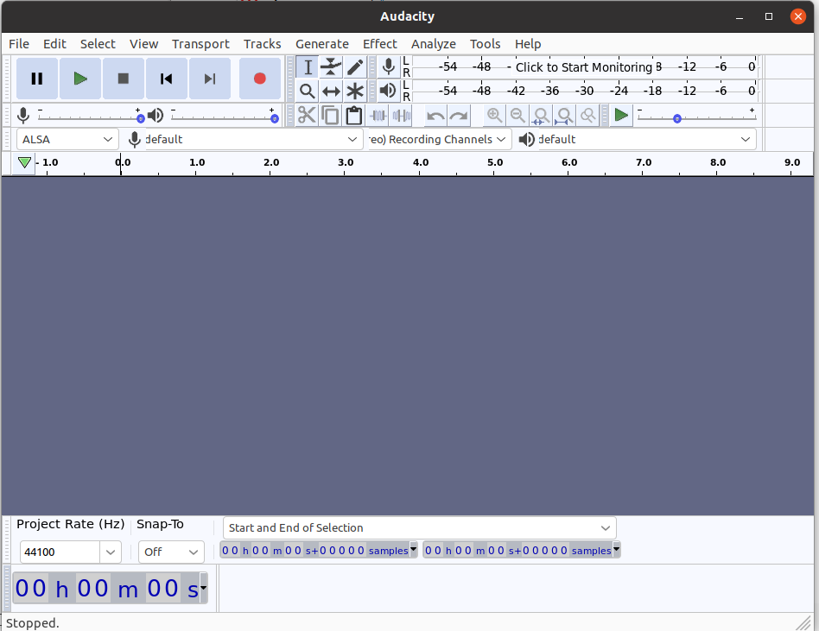

OpenShot video editor
A very intuitive video editor
sudo apt install openshot

A very simple video editor

Gnome Screenshot
Raspberry Pi has it’s own built in screenshot program, called scrot. It is a easy to use tool but it does require use of the terminal as it’s a command line tool. I prefer a graphical tool for most jobs so my choice for taking screenshots is gnome-screenshot
You can install it on the Raspberry Pi by typing:
sudo apt install gnome-screenshot

Note: Once installed you will find it under Accessories as Screenshot

