

Notes on LibreOffice Impress
Date Created 27-9-2021
Reviewed
Version 1

Description
A brief introduction to LibreOffice Impress

Typographic Conventions
Style | Description | Example
Text Body  Liberation Serif 10 | Normal body text | This is normal text
Key (Light Teal 4) | Keyboard shortcut | Press Ctrl + c to copy object
sudo su | Commands that should be run by the user | sudo apt update
menu | Menu Item | File > save to access the save feature

Table of Contents
Typographic Conventions 2
An Introduction to Impress 3
The Impress start screen 4
Creating a presentation 5
Slide Layouts 6
Setting up your slide show 7
Moving Slides 7
Gallery 8
Transitions 9
Animations 10
Using Outline View 12
Appendix 1 Guidelines for presentations 13
Structure 13
Introduction 13
Body 13
Conclusion 14
Questions 14

An Introduction to Impress
Impress is the Presentation program of LibreOffice.

In computing, a presentation program is a software package used to display information in the form of a slide show. It has three major functions:
- An editor that allows text to be inserted and formatted
- A method for inserting and manipulating graphic images
- A slide-show system to display the content.

Presentation software can be viewed as enabling a functionally-specific category of electronic media, with its own distinct culture and practices as compared to traditional presentation media. Presentations in this mode of delivery have become pervasive in many aspects of business communication, especially in business planning, as well as in academic-conference and professional-conference settings, and in the knowledge economy generally, where ideas are a primary work output. Presentations may also feature prominently in political settings, especially in workplace politics, where persuasion is a central determinant of group outcomes. Wikipedia

Note: Presentations of this media can become horrible if done badly.

The Impress start screen
Drop-down Menus
Title Bar
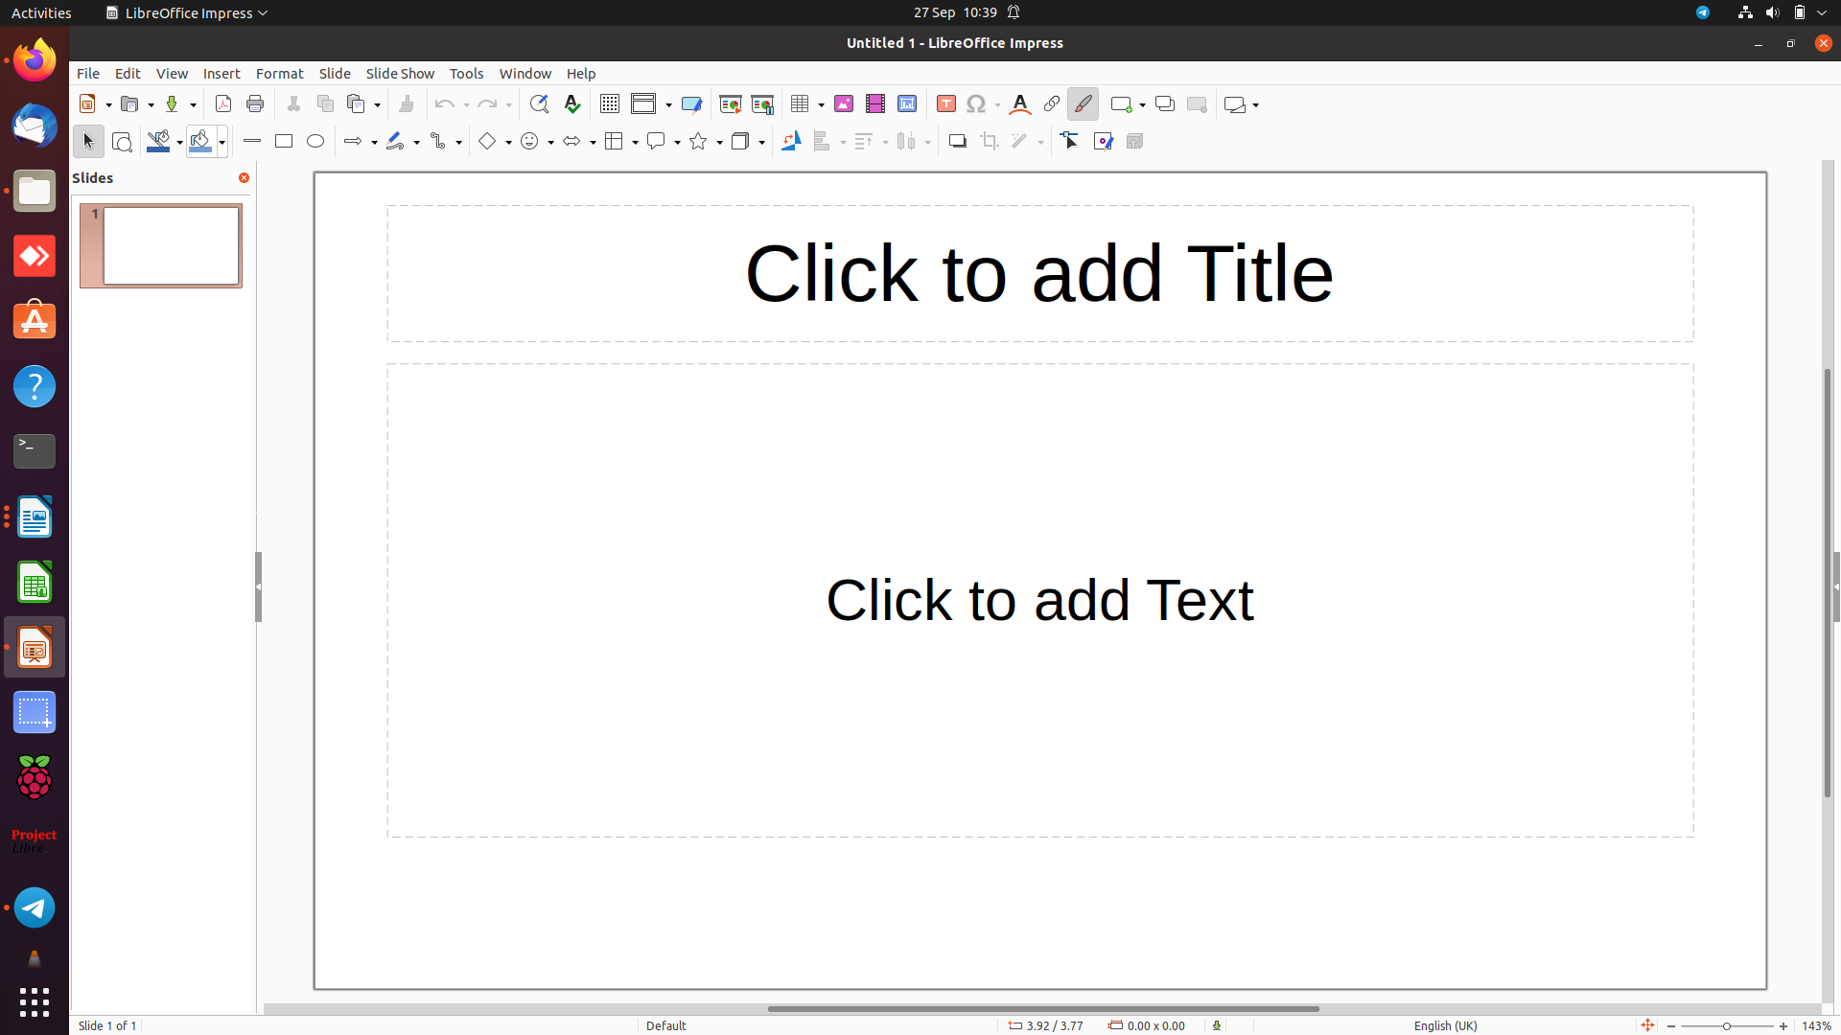
Workspace
Ribbon Tools
Slides sidebar
Like all LibreOffice applications the start screen consists of 5 parts.
At the top the Title bar which displays the name of the document and the application being used.
Next are the Drop-down menus for additional functions.
Below that are the Ribbon Tools that provide quick access to appropriate tools.
Then comes the main Workspace where you visualise your work.
Finally at the base we have the Status Bar which displays the current status of your document.
Additionally there can also be optional sidebars. Here we see the Slides sidebar.
One very useful feature is the Views Tab Bar
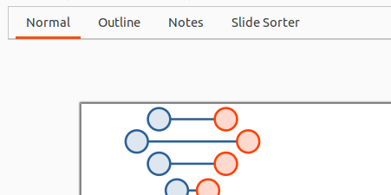

View > Views Tab Bar

Creating a presentation
Please check Appendix 1 Guidelines for Presentations before continuing.
When you start a new Impress presentation for the first time you can choose a variety of templates. Most of these I find too cluttered, however there is one, DNA, which I quite like. You will have to scroll down the templates to see it.

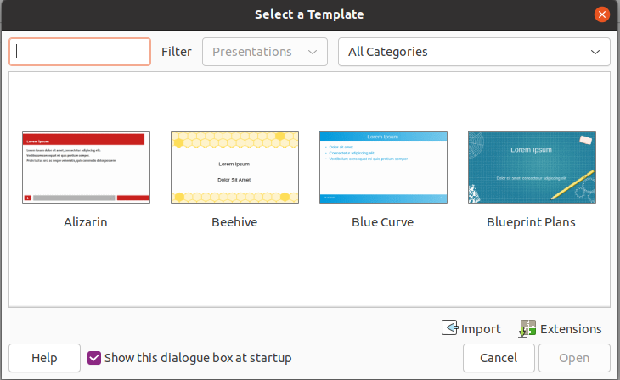
Once you have chosen a template you can start to build your presentation. I like something simple so I usually use DNA Of course you could choose to ignore the selection by clicking the Cancel button.
At this point I add the Title and sub-title of a presentation just so I feel I’ve made a start. I then save the presentation with file name the same as the title.
Note: You should save your presentation regularly and of course back it up, just in case!
Now you come to the content of your presentation. This is something you should think about before you continue. You will need to think of the order in which you want to display the content and the type of content you are going to use, Images, Media, Images and even Hyperlinks.
I strongly suggest this is done in the form of paper copies of your slides so you can feel confident in what you want to say before you start adding slides
Once you have the structure and content of your presentation you can start adding slides.
Adding text to a slide
Text is added to a slide by clicking the required text box and typing the text.
- Open a new presentation
- In the first slide put the title Making a Presentation in the Title box
- In the subtitle box put First impressions count
- Save the presentation as My Presentation

Slide Layouts
The default layout with Impress is the Title Slide layout. There are sixteen separate layouts. For most purposes the Title and Content slide layout are sufficient.

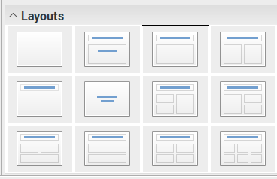
Title Slide
Title and Content Slide
Title Slide is used to set the title and subtitle of your presentation.
Note: It's a good idea to add your name to your first Slide.
Title and content is the most used slide layout. The content can be any one of Table, Chart, Image and Media.
Clicking on the appropriate icon in the centre of the layout will launch that type of content.
Open the Writer file Making a Presentation.
- If it is not open already open My Presentation.odp
- Create a new Slide (Title and Content layout) With the title Structure
- Add a bulleted list with the text Introduction, Body, Conclusion and Questions
- Continue to make a series of slides showing an audience how to make a presentation.
- Save the presentation as My Presentation to the same folder.
- Close the presentation.

Setting up your slide show

Moving Slides
Slides are best moved using the Slide Sorter view. Slides can be moved simply by dragging them to their new location.

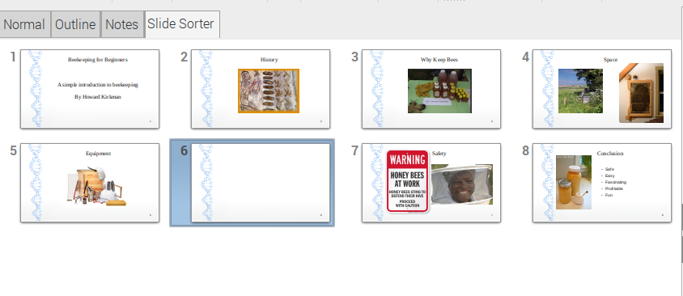

Continue using Making a Presentation.
- Move slide 2 to be the last slide position.
- Change the slide layout to Title Slide
- Delete this last slide
- Save the presentation as Making a Presentation Modified

Gallery
Impress has a large gallery of Clip-art which is available in the Gallery sidebar.
View > Gallery
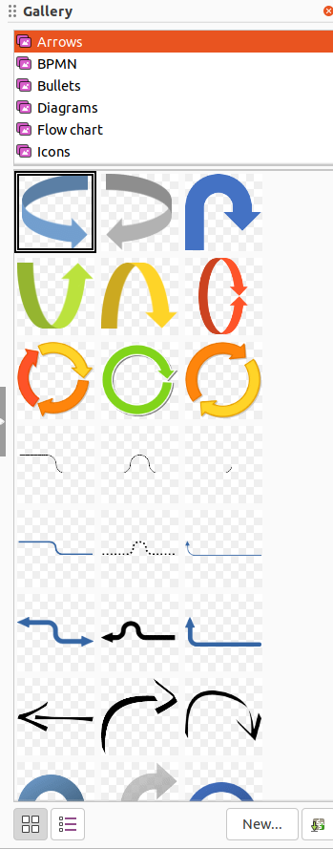

Transitions
Transitions control the way one slide mover into another. Transitions also have the ability to set options on sound and speed. The transitions can be effected on individual slides or on all the slides in a presentation. You will find the Transition Side Bar in the View drop-down
View > Slide Transition
- Select your first slide
- Select a transition from the Transition Sidebar
- Select other slides and apply different transitions
- View your presentation

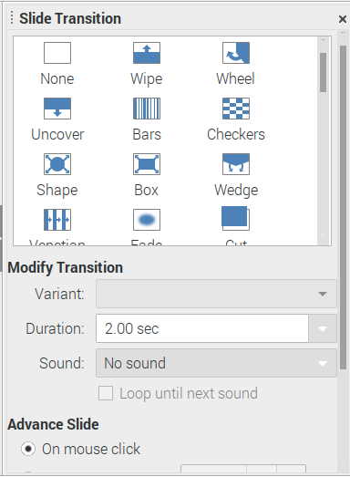

Note: Many presentations are ruined by Sound in the Transition

Animations
Animations are often used for bulleted lists. Each bullet will appear separately on the slide, usually after clicking the left mouse button. You must be in normal view to apply animations.

Select one of the slide bullets and choose an Animation from the View Drop-down.
View > Animation

The Animation Side Bar will show the Animations available.

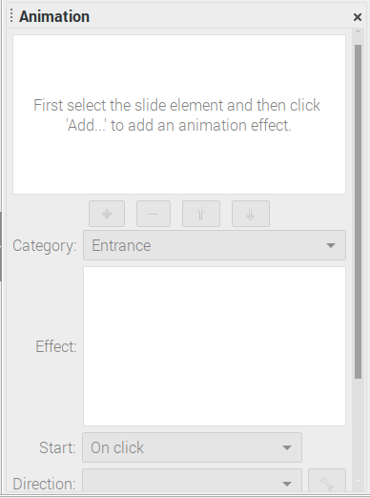

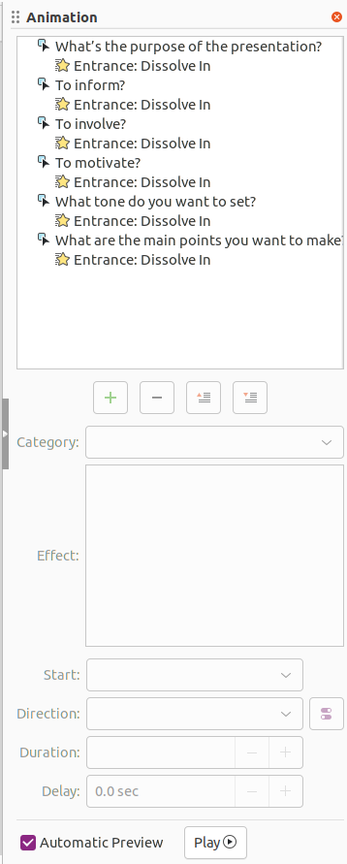

Using Outline View
Click Outline on the Views Tab Bar above the slide.

Note: if you don’t see the Views Tab Bar use View > Views Tab Bar

Switches to outline view where you can reorder slides and edit slide titles and headings.

The text in your slides will appear and you will be able to use the Text Formatting bar which contains the following icons for slide titles:

Promote, Demote, Move Up and Move Down.
If you want to reorder slide titles with the keyboard, ensure that the cursor is at the beginning of a title and press Tab to move the title one level lower in the hierarchy. To move the title up one level, press Shift+Tab.
The upper outline level corresponds to slide titles, and the lower levels correspond to the headings on a slides.
The best way to understand this is to use it.

Appendix 1 Guidelines for presentations

Structure
Most presentations will consist of an introduction, the body of the talk and a conclusion. The introduction prepares the audience for what you will say in the body of the talk and the conclusion reminds them of your key points. Good presentations raise questions in the listeners' mind. Good speakers encourage questions both during and after the presentation and are prepared to answer them.

Introduction
A good introduction does four things:
• Attracts and focuses the attention of the audience
• Puts the speaker and audience at ease
• Explains the purpose of the talk and what the speaker would like to achieve
• Gives an overview of the key points of the talk
It is often a good idea to begin a talk with a question, a short story, an interesting fact about your topic or an unusual visual aid. Many speakers follow this with an overhead transparency that shows the title, aim and outline of the talk.

Body
The body of a presentation must be presented in a logical order that is easy for the audience to follow and natural to your topic. Divide your content into sections and make sure that the audience knows where they are at any time during your talk. It is often a good idea to pause between main sections of your talk. You can ask for questions, sum up the point or explain what the next point will be. If you have an OHT with an outline of your talk on it, you can put this on the projector briefly and point to the next section.
Examples, details and visual aids add interest to a presentation and help you get your message through. Here are some questions you can ask yourself about the examples you include:
- Are they relevant to the experience of the audience?
- Are they concrete?
- Will the audience find them interesting?
- Are they varied?
- Are they memorable?

Conclusion
A good conclusion does two things:
• Reminds the audience of your key points
• Reinforces your message
Your conclusion should end the presentation on a positive note and make the audience feel that have used their time well listening to you.

Questions
Many speakers worry about questions from the audience. However, questions show that the audience is interested in what you have to say ad can make the talk more lively and interactive. You should be more worried if there are no questions at all! One way of handling questions is to point to questions you would like to discuss as you are talking. You can control questions better if you leave pauses during your talk and ask for questions. It is important not to let question and answer sessions during the talk go on too long, however. Answer briefly or say you will deal with the question at the end. Make sure you are ready to go on with your talk when questions have finished.

