

Spreadsheet Software
Date Created November 2020
Reviewed
Version 4.5
2/12/2020
Description
Basic introduction to LibreOffice Calc, the spreadsheet program of the LibreOffice Suite

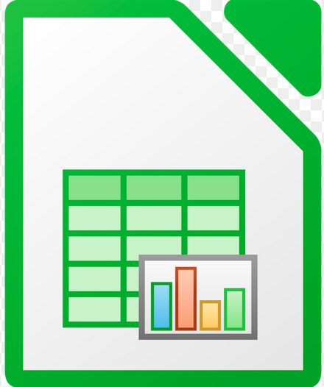

Table of Contents
Spreadsheet Introduction 3
Spreadsheet Principles 3
What is a spreadsheet: 3
The Layout of the top of the Calc Screen 5
The Layout of the bottom of the Calc Screen 6
Introduction to Spreadsheets 7
Spreadsheet Data and Structure 7
Input Methods 7
Storage and Retrieval of Files 7
Starting/Launching Calc 7
Create Spreadsheets 7
Storing / Saving Spreadsheets 8
Retrieve Spreadsheets 8
Document Editing 9
Enter and Insert Data 9
Edit Data 10
Undo 11
Cut, Copy and Paste 11
Find and Replace 12
Adding and Deleting Rows and Columns 13
Presenting Spreadsheet Information 16
School Budgets 16
Extra School Income 18
Analysis and Interpretation of Data 22
Summarise and Display Information 22
Creating Charts 24
Editing Charts 28
Add, remove a legend from a chart. 28
Page Layout 30
The Page style dialogue box 31
Check and Print 34
Check Documents 34
Printing 34

The work in this worksheet is accumulative. That is to get the best results you should work through these sheets in order.

Spreadsheet Introduction
This document is based on the LibreOffice Calc software. Calc is a spreadsheet package. In the document we will explain what a spreadsheet is and work through some examples of how to use them.

Spreadsheet Principles

What is a spreadsheet:
A spreadsheet package is a computer program created specifically to help in the processing of tabular information, usually numbers. The spreadsheet stores information in rows (across the screen) and columns (down the screen), forming a Worksheet (the term Calc uses for a single spreadsheet). Several worksheets are bound together (one initially) to form a Workbook, the name Calc gives to a saved file.
Spreadsheets are most commonly used to manipulate figures. They can be used in:
Accounting
Cash flows
Budgets
Forecasts, etc.

That said I use spreadsheets to generate lists of pupils to use as a register.

Any job involving the use of numbers can be done on a spreadsheet.

The biggest advantage that a spreadsheet has over other methods of manipulating
data - using a table in a word-processing application for example, is its ability to
constantly update figures without the user having to do any calculations. Once a
spreadsheet is set up correctly, its calculations will always be correct and any
changes in data are recalculated automatically.

Spreadsheets can also take basic data and present it in an attractive way, for
example as graphs, formatted lists, and tables.

Cells can contain, text (labels), numbers or formulas. The relationship between
Labels, Numbers and Formulas is shown below (remember this is a typical
example of a table - cell contents can be arranged in other ways).

“Age” Text that could be a label for a row or column .

“1234” Text that just happens to look like a number.

1234 The number one thousand two hundred and thirty four.

=A1+B1 The sum of two numbers in cells A1 and B1. If A1 and B1 do not contain numbers 0 is displayed in the cell containing the formula.

The Spreadsheet we are going to use is Calc. It is part of the LibreOffice suite.
All LibreOffice programs are Open Source and free. This workbook was written using Writer, the LibreOffice word-processor.

The Layout of the top of the Calc Screen

Title Bar
Drop down menus

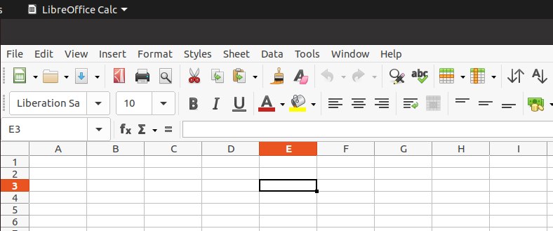

Ribbon
Tools

Row 2

Name Box E3 in this case because E3 is selected
Column E

Cell E3 selected

The Title bar. This is the grey bar across the top of the screen. It is called the title bar because it contains the title of the application you are running, in this case Calc and also the title of the document you are editing. If you have just started using Calc the document title is Untitled 1. Usually you will save this document with a new name before you start to write it. The title bar will then contain the file name you have given to the document.

On the right of the title bar are the Control Buttons, Minimise, Restore down/Maximise and Close. These allow you to control the size of the Calc window and to close it all together.


The Ribbon The ribbon is made up of a set of tools that each, in turn, effect some aspect of Spreadsheet work.
The ribbon is standard now in most office applications alongside drop down menus. As you work with different objects , charts, drawings etc. you will notice the ribbon tools change to the tools appropriate to the object you are working on.

The Task pane There are side bars that appear from time to time to help you work through a process e.g. Charts

The Layout of the bottom of the Calc Screen

At the bottom of the Calc screen on the left you have the sheet tools. Below you can see we only have one sheet, Sheet1, in this workbook.
If you want add new sheets to your workbook use the large plus.
Add new sheets tool

Current Sheet
Use these tools to move from one sheet to another

When cells with numbers are selected the Sum and Average of those numbers are displayed here
Increase and decrease the view

Introduction to Spreadsheets

Spreadsheet Data and Structure
By the end of this course you will know the types of data that are needed in spreadsheet files: numbers, graphs or charts, text, images
You will understand spreadsheet components and their layout: cells, rows, columns, sheets, pages, graphs or charts.

Input Methods
There are a variety of input methods used with spreadsheets, the most used being the keyboard. Other input devices could include touch screen, voice recognition, and stylus.
We will only be using a keyboard and mouse.
By the end of this course you will realise how important it is to enter data into your spreadsheets both accurately and efficiently.

Storage and Retrieval of Files

Starting/Launching Calc
The image representing LibreOffice Calc is it is used to launch Calc.

Depending on how things are setup on your computer it will be in different places on the Raspberry Pi it is under the Raspberry start tool on the Office tab.
To launch Calc simply click on this image.

Create Spreadsheets
There are three important tools on the Calc ribbon
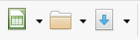
Save your Workbook
Create a New Workbook

Open an Existing Workbook

Note: When Calc first opens it creates a new workbook for you.
If you want to create another workbook simply click on the Create New Workbook tool.

Storing / Saving Spreadsheets
Saving / Storing your work is often poorly understood. This is because too often things are done for you without any explanation. Before embarking on a project it is important to plan where you will save your work. This is particularly important when working with others and / or a remote storage device called a server is used.
If it’s only you involved then it is still important to have an idea of where you will store your files in a tidy manner. It is no different to storing things in a filing cabinet. Untidy storage always leads to confusion and time wasting. If you are working with others check to see if there are any guidelines you should adhere to, particularly naming conventions.

Note: When Saving a workbook the extension .ods will be added automatically.

Retrieve Spreadsheets

To find and open a previously saved spreadsheet file. Click on the Open an Existing Workbook tool

Note: The Clicking the small upside-down triangle to the right will display recently saved files

Task: Create a New Workbook for Student Marks. Save this Workbook as Student Marks in a Folder in your Documents folder called Students
Close this workbook and then re-open it.
Note: It is a good idea to create the Students folder before you start. It is also a good idea to save your workbook before starting to work on it. Finally it is always a good idea to save your work regularly as you go along.

Document Editing

Enter and Insert Data
When you use a spreadsheet each cell should only contain 1 element of data. For example:
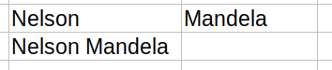
✓


This is because it is difficult to manipulate data, e.g. sorting, when it is grouped. More on this later.

Open In your workbook Student Marks.ods
In cell A1 write the title of your workbook, choose something relevant to you like Grade 7 2020
It should look something like
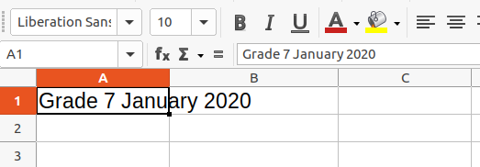

In this case the text typed has gone into cell B1. Had something been in cell B1 everything after Janu would be hidden. Save this workbook
In cell A2 enter the First name of one of your pupils.
In cell B2 Enter the Family of one of the same pupil
Your sheet should look something like
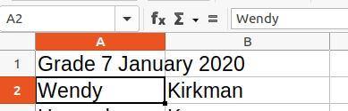

Note: cell A2 is selected and A2 appears in the Name box
Continue adding six Pupil names to your worksheet.
Note: Since this workbook may be passed on, to me for example, you should not use any pupil’s real identity. Always keep student’s data secure.
Make up some names to complete this task.
If you have already added real pupils names simply select the cell and press the Delete key to delete its contents. You can select multiple cells by hovering over a cell, holding the left mouse button down and moving the mouse to select the range of cells you want. Pressing the Delete key deletes everything covered by the mouse range. Be careful!

Edit Data

Note: Selecting a single cell is just a case of clicking on it
To select a range of cells click and hold on the first cell and move the mouse pointer to the last cell and release the mouse button.
To select a range of cells not adjacent to each other hold the CTRL key down while you select the cells you want. If you make a mistake simply select the cells again and they will be deselected. Keep the CTRL key held down until you have finished your selection
To delete the contents of a cell select the cell and press the delete key
To Edit the contents of a cell select the cell and do the editing in the formula box

Cell to be edited
A1
Edit here
Called the Formula box

Undo
To Undo the last action in a spreadsheet use the undo tool to redo something you undid use the redo tool.
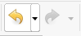
The Redo tool. It is “greyed out” because the Undo tool has not been used so there is nothing to Redo
The Undo tool, it undoes your last action

Cut, Copy and Paste
Three tools allow you to easily move data in cells from one part of a worksheet to another. They are Cut, Copy and Paste.
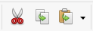

Cut
tool
Copy
tool
Paste
tool

These three tools each have a keyboard shortcut:
Cut CTRL + x Think of a scissors
Copy CTRL + c Think of Copy
Paste CTRL + v Think of moVe

So to Copy data from one cell to another select the cell and either use CTRL + c or the Copy tool to grab the data. Then select the cell where you want to move the copy to and either use CTRL + v or the Paste tool to paste the data into that cell
Note: If you are wondering why not use CTRL+p, it is because that combination is already used for Printing.
To move rather than copy use CTRL+x or the Cut tool. Then Paste into the new cell with CTRL + v or the Move tool

Find and Replace

Use the find tool to locate data within a spreadsheet.
Use a simple replace tool if you know what it is you want to find and you know what you want to replace it with.
Both find and replace are in the Edit drop down menu.
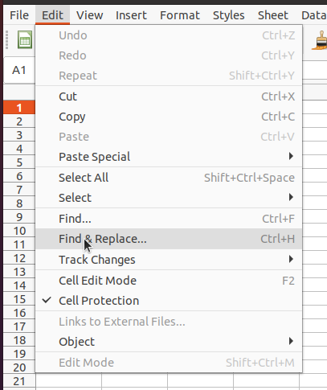

Note: they both have keyboard short-cuts
CTRL + F to find something
and
CTRL + H to find something and replace it with an alternative.

Adding and Deleting Rows and Columns

In order to make your sheet more readable sometimes you need to put blank rows and columns into you sheet.
Open your sheet Student Marks.ods
Insert a blank row between the title and the first pupil

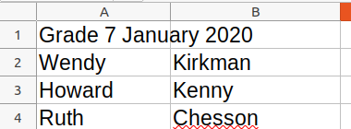
Insert a new row here

To do this Right click on the number 2 and select Insert Rows Above
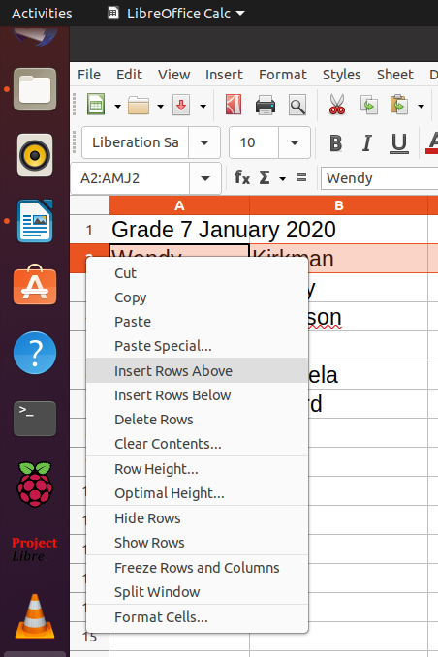

By clicking on the 2 you select the whole of the second row
This will insert a row above the current row 2

If you selected row 1 you would need to insert the row below to get the same result

Add the headings Fname and Sname
Once you have inserted the row correctly you can close your workbook.
Having a list of pupils is useful but a sheet really comes into its own when you add some numbers to it and start to analyse and interpret it.
For now imagine you have the results of three tests, Art Maths and English.
Enter these results alongside each pupil. You might want to add a header to the columns you choose for the subjects.
Your sheet might look something like:
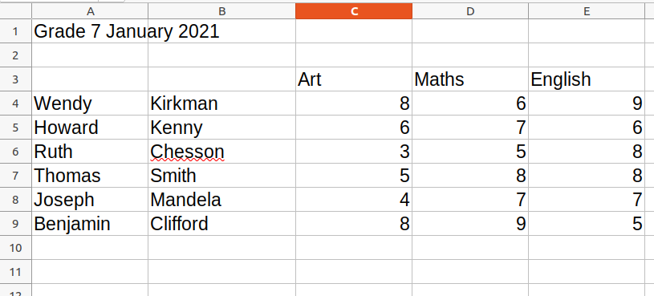
Suppose we wanted to find the average mark in the Art column we would use the AVERAGE function built into the application
=AVERAGE(C4:C9)
The = at the start of the function tells the cell some calculation is to be done.

In cell C10 type =AVERAGE(C4:C9) and press the enter key
Check that the average is the same when done with a pen and paper.
It might seem a bit long winded but checking calculations with test data is critical when using complex systems.
Continue to complete the averages for each subject.
Using the same function calculate the average mark for each pupil over the three subjects
Save your work.
Note: It is good practice when creating lists or tables in a spreadsheet to avoid blank rows and columns in the main body of the list or table, insert a blank row before a Total row and ensure cells bordering a list or table are blank.

Your sheet will look something like this:
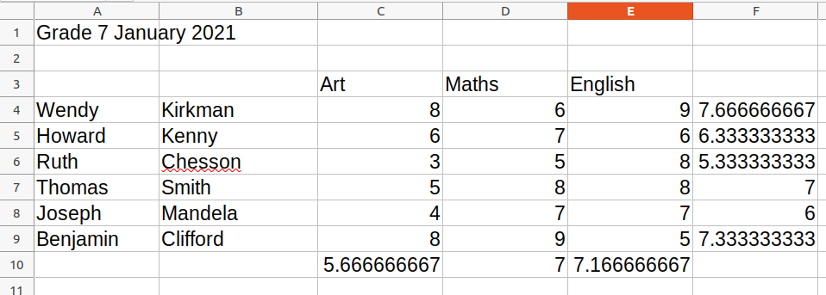
Obviously this need tidying up!
One way to do this is to round the results and this can be done with the ROUND function.
The final calculation, for the Art test will be:
=ROUND(AVERAGE(C4:C9))
Don't forget the second bracket at the end because we are using two functions.
The new results are shown below.
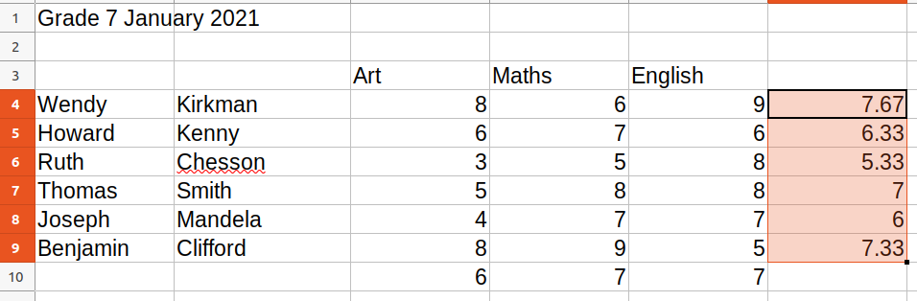
ROUND(AVERAGE(C4:E4),2)

The round function can also include a comma followed by the number of decimal places needed as in the highlighted column above.
Place a blank row and column to separate the totals.
Complete your sheet and save it.

Presenting Spreadsheet Information

School Budgets

For this exercise we shall be focusing on formatting Cells, Rows and Columns and improving the overall presentation of your work.

We will use part of the schools budget to do this. Create a new sheet to include the following detail

Utility Bills
Motor Vehicle Servicing
Fuel and Lubricants
State and Public functions
Office Equipment Servicing
Insurance

Add an appropriate title and invent some likely costs and include them.

Check the spelling of your worksheets using the spelling tool.

Your sheet might look something like the one below below.
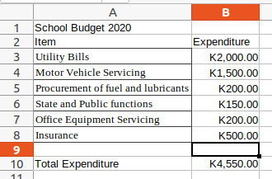

The total Expenditure in row 10 was calculated using the SUM function

Cell B10 contains the calculation =SUM(B3:B8)
Meaning
Add the values of the contents of cells B3 to B8 inclusive.

Format the cells which will contain currency to reflect the currency in use ie the Zambian Kwatcha ZMW.
To do this Click the Format tab then select Cells. This will display the Cell Format dialogue box
Make sure the Numbers tab is displayed. Select Currency from the Category list and ZMW from the Format list
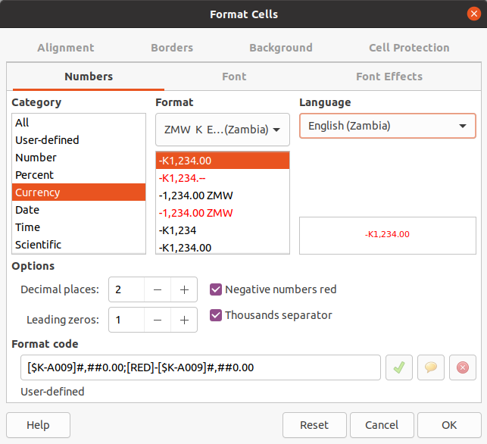

Extra School Income
This sheet is going to be part of the school budget workbook, School Budget.ods so open this file.
This work is going to be on a new worksheet in this workbook.
To create a new sheet click the + on the bottom left of your sheet
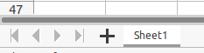
Add new sheet tool

Double click here to edit the sheet name

Note: You can double click on the sheet name, Sheet1 in this instance, to edit it

Look at the worksheet below and enter everything except the numbers in column E. We are going to let the spreadsheet do the calculations for us.

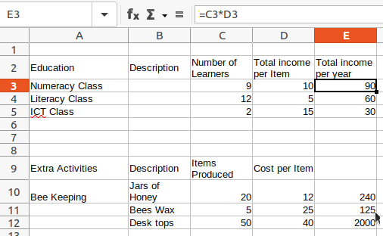

If you look closely at the example above you will see cell E3 contains the number 90. However if you look at the formula bar you will see it displays =C3*D3. Can you work out what's happening here?
E3 actually contains the formula =C3*D3, you must always have the = sign at the start of a calculation when using spreadsheets. 90 is the product of cell C3 and cell D3.

Lets look at row 2 for a moment.

I hope you agree it looks better than

Which is what you get when you just type the text in. So let’s fix things
If you haven’t already done it type the text above for row 2 into your worksheet. Then click on the number 2 to select the whole row. If you only wanted to select the cells you are working with then click and hold the mouse button and drag the cursor until all the cells you want are selected then release the mouse button.
With the cells selected click on the Format Drop-down menu and select Cells
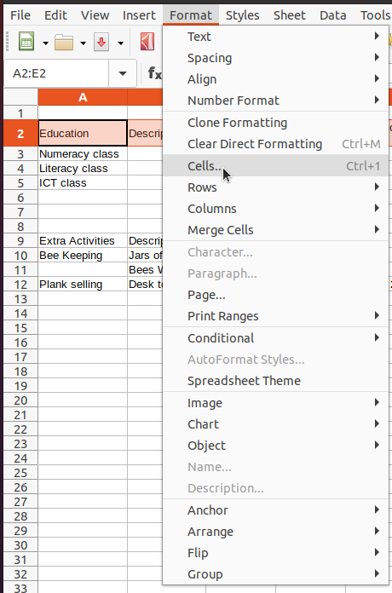

This will open up the Format Cells dialogue box (See next page)

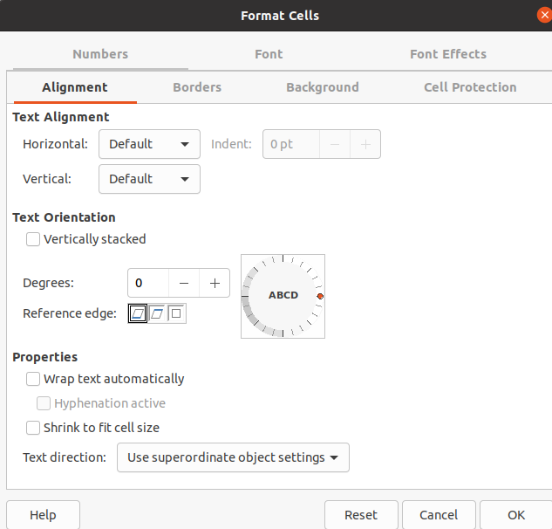

The Format Cells dialogue box

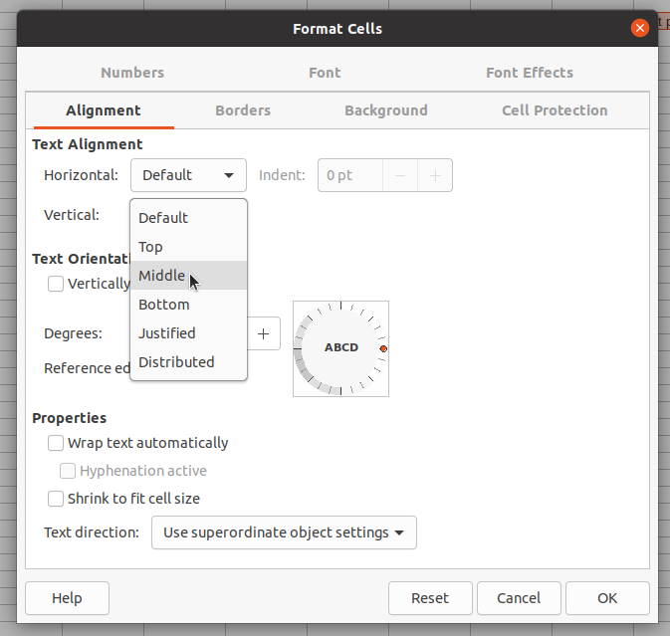

To get the text to be vertically aligned choose Text Alignment, Vertical and then select Middle from the drop-down selection.

To get long pieces of text to automatically wrap into a cell select the Wrap text Automatically check box.

There are many other options for Cell properties. Please experiment, you can always use the undo tool if things go pear-shaped

Format cells to display numbers to a specific number of decimal places.
Format cells to display numbers with or without a thousands separator.
Add borders and shading to selected cells, rows, columns.
Change cell alignment: left, centre, right, top, middle, bottom.
Change cell formatting: font style, font size.
Adjust row height, column width.

Analysis and Interpretation of Data

Summarise and Display Information
One of the strengths of Calc, or any spreadsheet application is that it can easily display data in a graphical and form which is usually much easier to interpret. We are going to use a set of data collected on the Annual Temperatures Rainfalls in both Siavonga and London to demonstrate this.
The data we will use is handwritten below.

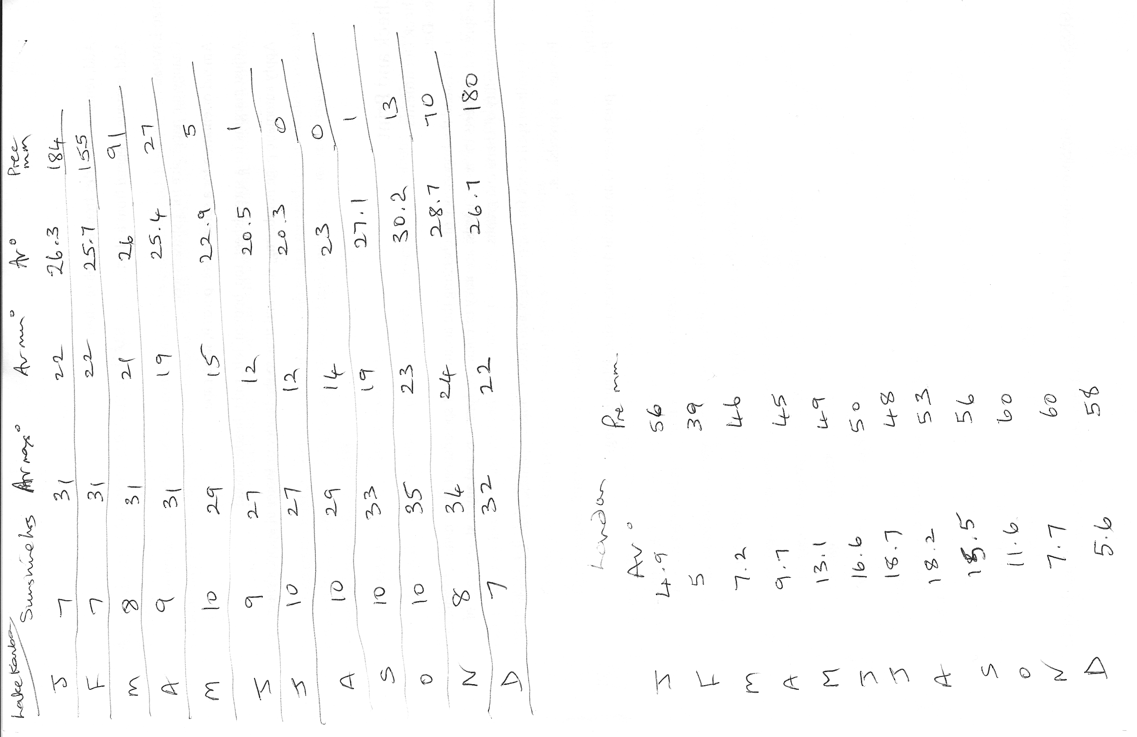

Think about why you might want to put such data as this into a spreadsheet
What are the advantages of using a spreadsheet?

Create a new workbook and give it a name that helps you remember that it contains weather data for Siavonga and London.
Save your work.
First in row 1 enter the months of the year Jan to Dec.
This is going to be easier than you think, enter Jan in cell B2
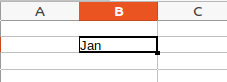
Notice the small black square in the bottom of cell B2.
Click and hold the mouse button on this. Notice, once in the corner, the cursor changes to a cross + drag the mouse to the right until Dec is displayed. This should take you to cell M3.
Having got the months on row 2 type the corresponding Rainfall (in mm) into row 3.
To do this more easily click and hold the cursor over cell B3 and, still holding the mouse button down, drag the mouse pointer to cell M3.
Notice cell B3 is highlighted. Without using the mouse at all type the values into cell B3 and press the enter key. This will allow you to enter the data one cell at a time with an automatic move to the next cell once the enter key is pressed

Continue entering data until it is all entered.
Tidy your sheet by adding a title in cell A1 and inserting a blank row above row 2
Notice when you press the enter key for the December entry the insertion cell B3 is selected.
Click in the empty cell to the left of January’s data (184). Type the units of rainfall, in this case mm
Your sheet should now look like this
Save your work.
As you can see the data in the sheet is much clearer than on paper.

Creating Charts
Open your weather file, if it isn't open already.
Select all the cells from A3 to M4
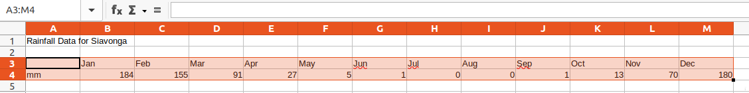

Now we are going to use the Charting tool tool to create a bar chart
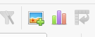

Insert chart
Insert image

The charting wizard appears to guide you through the processing
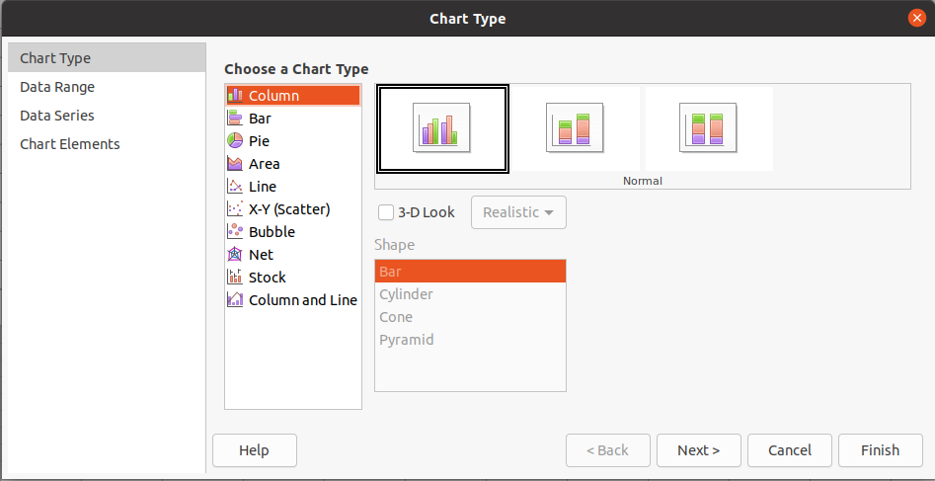
The Column chart type is selected by default and it will appear in the background, however select the Line chart type and from there choose Points and Lines

Once you select Points and Lines click Next
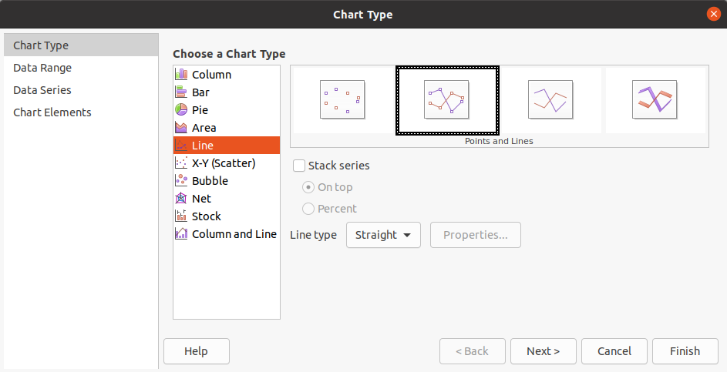
The Data Range dialogue box appears and because we highlighted the range it has been selected for us. Similarly the data series, First row as label and First column as label are also selected. Again click next to continue to the next dialogue box

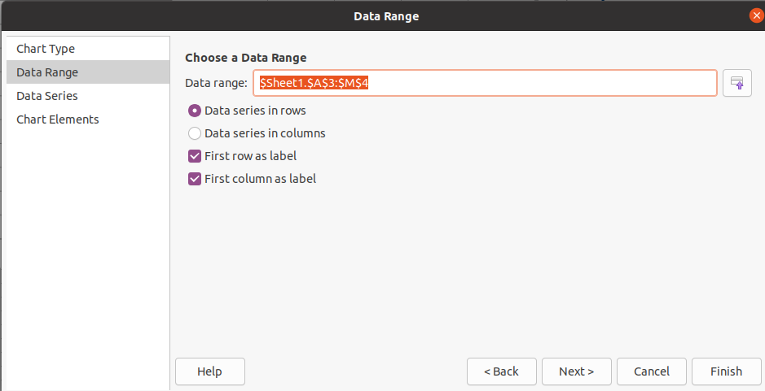

Data Series Dialogue box
Because we selected the data before we started there is nothing to do here so click Next
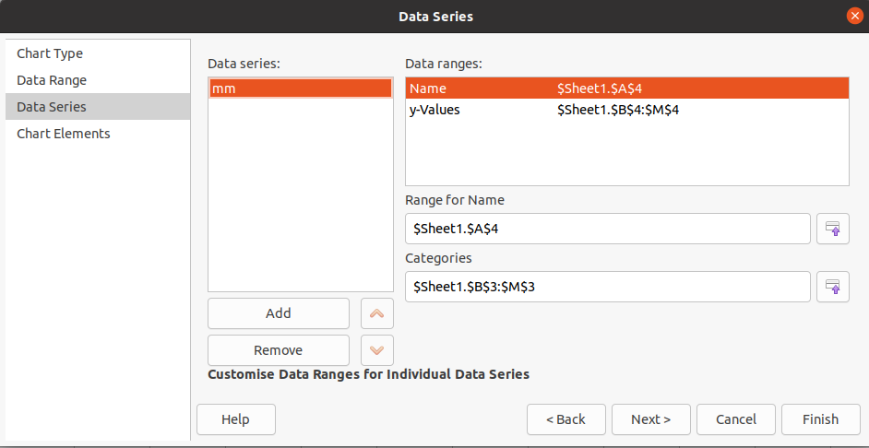
Chart Elements Dialogue box.
Complete as shown
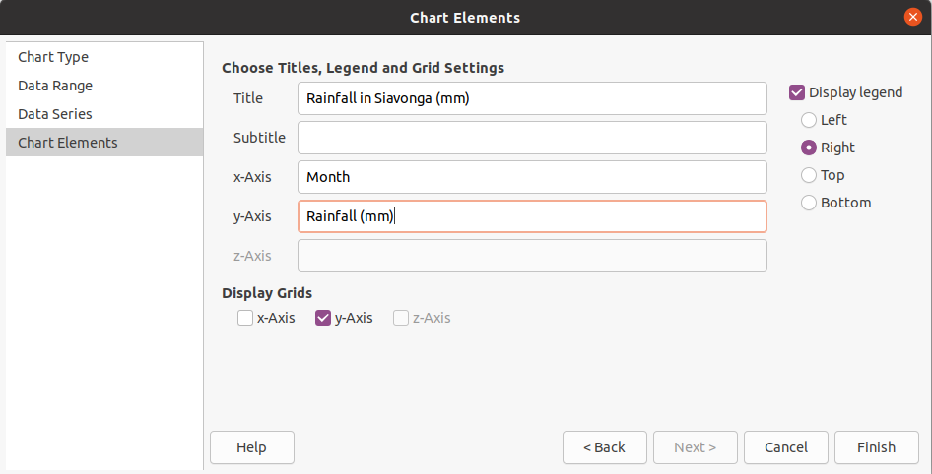
Click Finish

Your finished graph should look something like
Now produce a similar chart for Siavonga average temperatures.

Editing Charts
Be able to identify appropriate graph or chart types to display required information effectively.
Create different type of graphs or charts from spreadsheet data: pie, bar, single line.
Select a chart.
Add, remove a title from a graph or chart.
Add, remove axis titles from a graph or chart.

Add, remove a legend from a chart.

Understand the tools and techniques available to summarise and display information: totals and summary information, sorting and display order, lists and tables, graphs and charts.
Be aware that you should judge when and how to use the available tools and techniques effectively to display the required information.
Recognise good practice in creating lists or tables in a spreadsheet: avoid blank rows and columns in the main body of the list or table, insert blank row before Total row, ensure cells bordering list or table are blank.
Create a list or table in a spreadsheet.
Sort a list or table by one criterion in ascending, descending alphabetic, numeric order.
Functions and Formulas
Be aware of the need to ensure that any formulas and functions used are designed to meet calculation requirements: use cell references rather than type numbers into formulas, use of parentheses to determine order of calculation.
Create simple arithmetic formulas in a spreadsheet: add, subtract, multiply, divide.
Use common functions in a spreadsheet: sum, average, round.

Page Layout
To change the page details select the Format drop down then select Page.

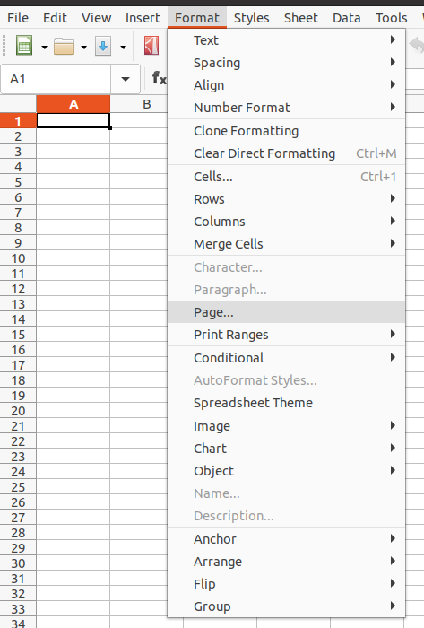

The Page style dialogue box will appear and you can set the page orientation, margins and size to suit your requirements. See next page for more detail.

The Page style dialogue box
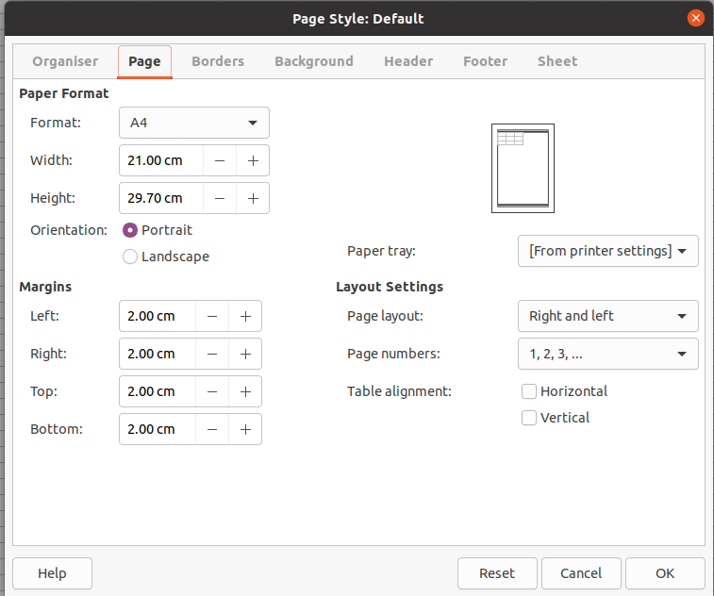
Change orientation for a spreadsheet: portrait, landscape.
Adjust margins for a spreadsheet: top, bottom, left, right, header, footer.
Paper size

Headers and footers can be used from the Header or Footer tab.
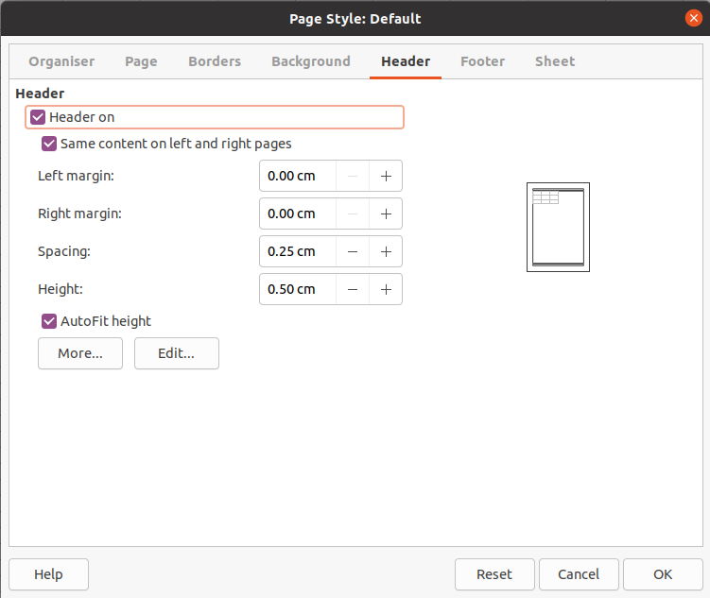

Click Edit to add content to your Header

As you can see the Header (and Footer) is divided into three areas. You can type directly into these areas or you can select the Custom header tools

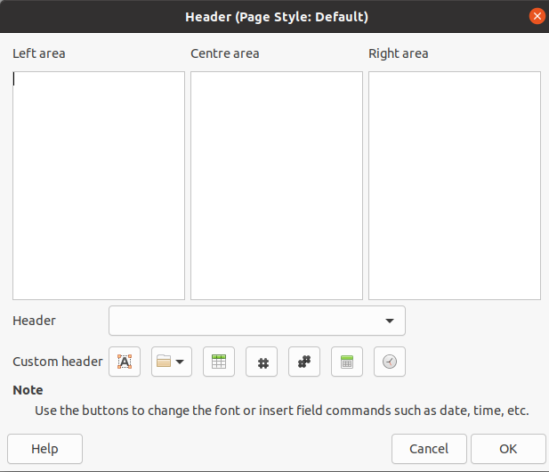

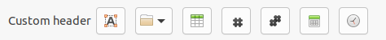

The custom header tools allow you to insert elements into your header or footer.
Text attributes such as Font, Style and Size

Title such as Title File name and Path

Sheet name

Page number

Number of pages

Date

Time

The last tab, Sheet allows you to customise how your sheet is displayed
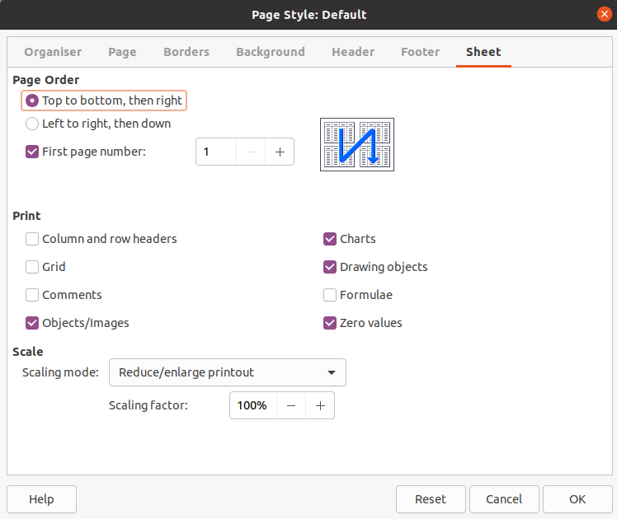

Check and Print

Check Documents
Test Data
Test data is used to establish the spreadsheet has been correctly set-up. This is particularly true for complex solutions. It is important to check the accuracy of spreadsheet information, and to ensure the spreadsheet meets the user's needs: accuracy of numbers, formulas and any text, accuracy of results, suitability of charts and graphs etc.
Use the built-in spell check tool for a spreadsheet and make any necessary changes: spelling, repeated words.

Spell check tool

Printing
There are three closely related tools on the ribbon for Printing and producing pdf files
Before printing a spreadsheet to an installed printer it is usually a good idea to preview the printing

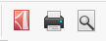

Export to PDF
Print
CTRL+p
Print preview

