

Notes on sorting
Date Created : February 2021
Reviewed
Version

Description

Sorting data

Note: Generally it is not a good idea to try to sort data without taking care to plan ahead.

To do this exercise, open the file Sort1

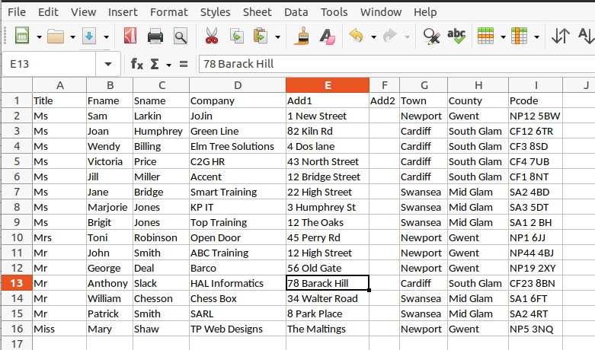

Note: Before you use this file make sure all the text is visible. This is not strictly necessary but I want you to do this to practise the things we have learnt.

To quickly sort a list simply click on one of the the sort tool in the ribbon.

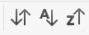
Open the sort dialogue box
Sort Decending

Sort Assending

You can easily sort items in ascending or descending order. Note Calc by default expects a header on each column.
The sort is based on the column where a cell is selected.
If your data does not have a header row or you want more than a simple sort then select Data drop down menu and then Sort this opens the Sort dialogue box. You could also open this by clicking the first of the sort tools, the up and down arrows.
The first tab Sort Criteria lets you set-up a variety of sort criteria.

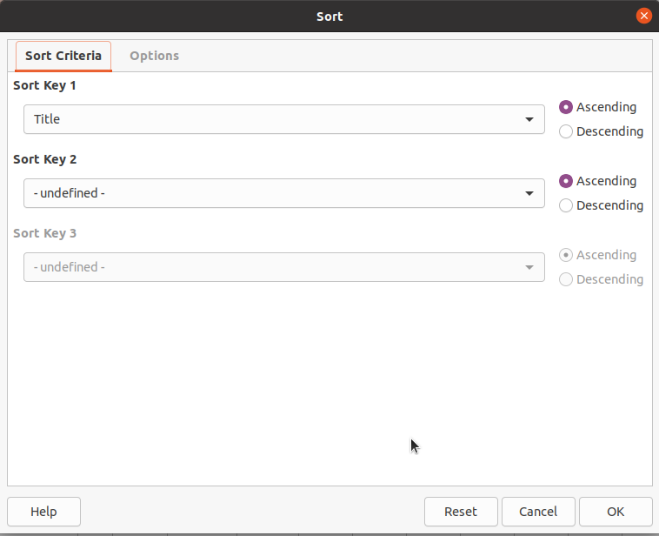
Title was selected because a cell in that column was highlighted

The second tab, Options lets you choose

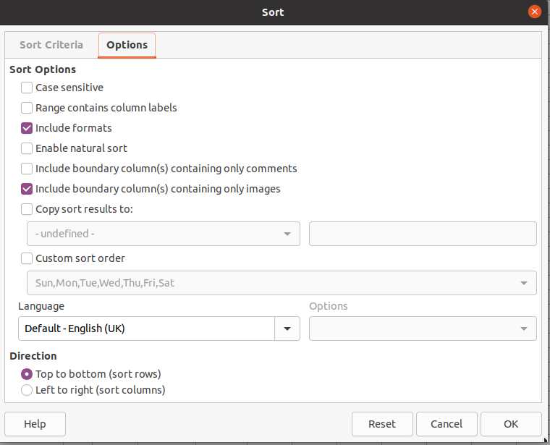
If your data has no header row be sure to uncheck the Range contains column labels check box.

Sort1 contains the names of customers of a particular company. The sales director wants to see the areas where his clients are based. The quickest way of doing this is to sort the list by postcode.

- Sort the data in sort1.ods by postcode
Select the data you want to sort. If there are no empty rows or columns then you can simply select any cell in the table. This is not, however, recommended.

Select Sort from the Data drop-down menu in the ribbon. From the drop down menu select sort.

The first thing to note is if the options tab dialogue box has the Range contains column labels check box is checked. If your data does have headers, and most data tables do, then this box must be checked else the top row will be treated as any other row. Try clicking the Sort key 1 selector, first with the My data has headers check box checked then without it checked. You will see the first column headers are available to be selected or else just the column letters.

Select the Pcode header and click OK. The data is now sorted in Pcode order.

Note
You can also filter the data by turning on the filter tool.
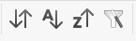
Filter tool

Once the filter is on, use the arrow in the column headers to choose a filter for the column.

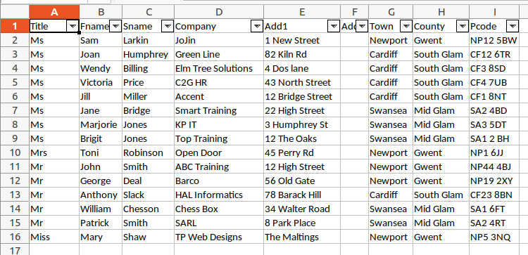

- Open the file Hotel Visitors.ods and Sort the data in order of Hotel (column A).
- Save the workbook as Hotel visits.ods

