

Spreadsheets Level 2 (Intermediate)
Date Created May 2021
Reviewed
Version

Description
Spreadsheets using Calc Level 2 (Intermediate)

Typographic Conventions
Style | Description | Example
Text Body  Liberation Serif 10 | Normal body text | This is normal text
Key (Light Teal 4) | Keyboard shortcut | Press Ctrl + c to copy object
sudo su | Commands that should be run by the user | sudo apt update
menu | Menu Item | File > save to access the save feature

Table of Contents
Typographic Conventions 2
Manipulating Data/Named Ranges 4
Paste Special 4
Transposing Data 7
Transpose data from column to row 7
Transpose data from row to column 8
Importing Text and Delimiting by Space, Comma or Tab 9
Exchanging Data Using CSV Files 9
Import Dialogue Box options 11
Character Set 11
Language 11
From Row 11
Separator Options 11
Fixed width 11
Separated by 11
Tab 11
Semicolon 11
Comma 11
Space 12
Other 12
Merge delimiters 12
Trim spaces 12
String delimiter 12
Other options 12
Format quoted field as text 12
Detect special numbers 12
Skip empty cells 12
Fields 13
Column type 13
Preview 14
Naming Cell Ranges 15
Naming Ranges within Formulas 17
Navigating Through Workbooks Using Named Ranges 18
Creating Named Ranges Automatically Based on Cell Values 18
Deleting Named Cells/Ranges 18
Creating Subtotals 18
Removing Subtotals 18
Templates 18
Formatting and Display Techniques 18
Sorting and Querying Data 19
Linking and Consolidation 19
Chart Formatting Techniques 19
Database functions 21
Protection and Security 22

Manipulating Data/Named Ranges

Paste Special
Paste Special is a feature that gives you more control of how the content is displayed or functions set when pasted from the clipboard. Paste special is a common feature in productivity software such as LibreOffice. It is very commonly used in Writer and Calc to provide special formatting or calculations when pasteing content into a document.

For example, text copied from a web page often retains much or all HTML formatting, which may not match the colours, fonts, or other text formatting used in the document. Using paste special, you can choose to paste unformatted text (doesn't have a different font, isn't bold, doesn't contain links, etc.). Below is an example of the choices that are offered when using paste special in LibreOffice Writer.
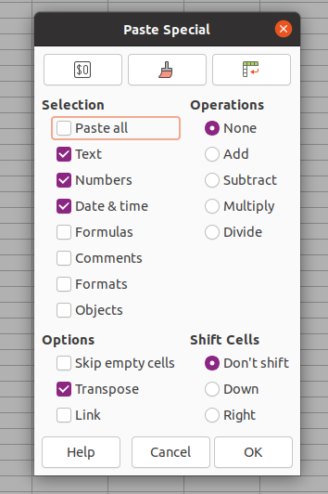
These are the default settings for Paste Special with the exception of Transposed which has been ticked ready to transpose some data for this booklet.

This supposes you have already got something to copy!
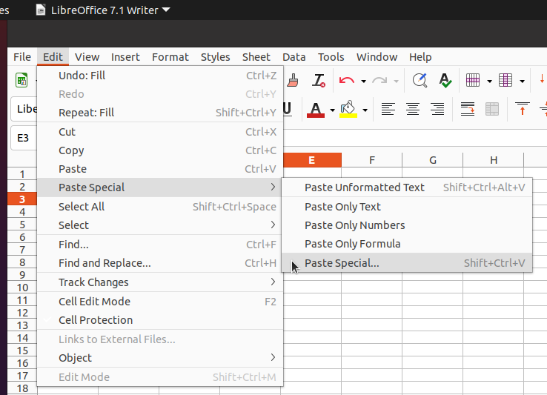
From the Edit menu click Paste special to open a dialogue box similar to the above example. If you want to paste text that is not formatted, click Unformatted text. You can also use any of the other options presented. Options that are not available are greyed out. If you select Paste Special this will open a dialogue box which contains the many options available

In this case the option to Transpose has been selected. The results of this choice are shown below. Notice there is a shimmering around the area to be pasted.
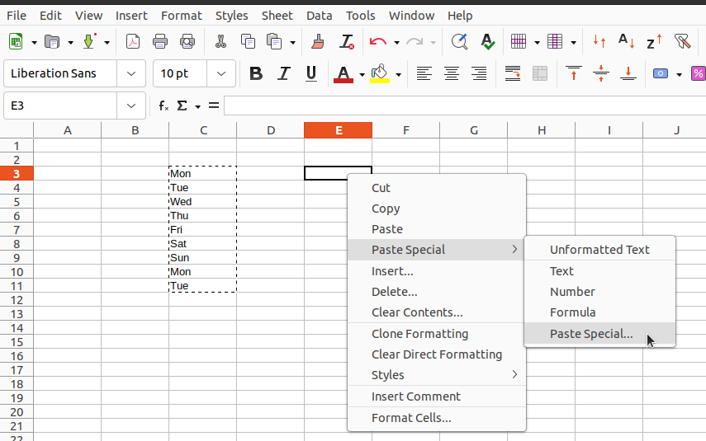

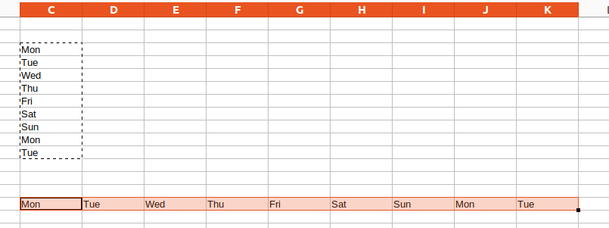

Transposed

Paste Special allows you several choices of how to format text when pasted. In the same way, you can use this command in Calc to copy formulas and calculations when pasting data into cells.
Original data with Total column displaying the calculated costs
Item | Quantity | Unit cost | Total
Wash Stations | 2 | 130 | 260
Soap | 5 | 23 | 115
Masks | 100 | 20 | 2000
Disinfectant | 2 | 350 | 700
Face shield | 20 | 60 | 1200

If you show the formula it would look like this

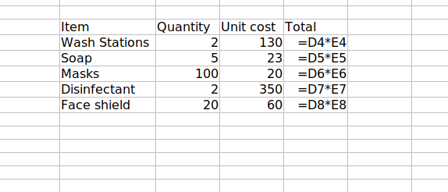

The Result of past Special with Formulae ticked. The Table is ready to use again with the formulae intact.

Item | Quantity | Unit cost | Total
Wash Stations |  |  | 0
Soap |  |  | 0
Masks |  |  | 0
Disinfectant |  |  | 0
Face shield |  |  | 0

Transposing Data
When working with data in a LibreOffice Calc spreadsheet, you may need to convert, or transpose, data in columns to rows, or rows to columns. Transposing data is useful to present data in a different layout or copy data from a spreadsheet to another program requiring another layout. For example, you may have monthly budget data in column format, with the month names in one column and sales amounts in a second. You can transpose the monthly budget data into two rows instead of columns.
To transpose data in Calc, select the direction to transpose data below and follow the steps.

Transpose data from column to row
To transpose data in Excel from column to row, follow the steps below.
- In the Excel spreadsheet, select the cells containing to data you want to transpose. The data should be contained in one or more columns.
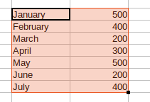
- Press Ctrl+C on your keyboard to copy the selected cells.
- Using your mouse, select the cell where you want to convert the column data to row layout. You can select a cell in the current worksheet or a new worksheet contained in the same spreadsheet file. In our example, we are selecting the cell in row 10, column A.
- Right-click the selected cell and select the Paste Special option.
Note: You can also bring up this dialogue box with Ctrl+Shift+v
- In the Paste Special window, click the box for the Transpose option, then click OK.

- The data is pasted in one or more rows, depending on the number of columns you selected. For example, if there are two columns of data, transpose converts the data into two rows of data.

Transpose data from row to column
To transpose data in Excel from row to column, follow the steps below.
- In the Excel spreadsheet, select the cells containing to data you want to transpose. The data should be contained in one or more rows.

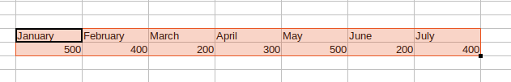

- Press Ctrl+C on your keyboard to copy the selected cells.
- Using your mouse, select the cell where you want to convert the row data to a column layout. You can select a cell in the current worksheet or a new worksheet contained in the same spreadsheet file. In our example, we are selecting the cell in row 7, column A.
- Right-click the selected cell and select the Paste Special option.

- In the Paste Special window, click the check-box for the Transpose option, then click OK.

- The data is pasted in one or more columns, depending on the number of rows you selected. For example, if there are two rows of data, transpose converts the data into two columns of data.
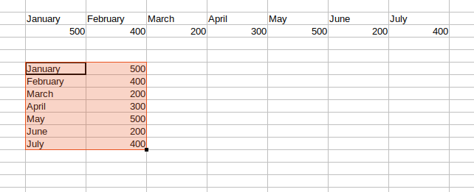
Transposed

Importing Text and Delimiting by Space, Comma or Tab
~~~~~~~~~~~~~~~~~~~~~~~~~~~~~~~~~~~~~~~~~~~~~~~~~~~~~

Exchanging Data Using CSV Files
CSV (comma separated variable) files are just about the simplest format you can use for holding data. In this most basic of structures each piece of data is separated by a comma and each record is on a new line. Because this format is so simple it is often used to transfer data from one application to another.
To look at the data in a csv file simply open it with a text editor such as nano.
Note: If you open a csv file with a word processor the word processor will add unwanted characters to the text, which you won't see and this will corrupt the data
Task 1
Using Notepad find and open the file sample data.csv, examine the data and decide what the data represents then close the file. Do the same for the file data.txt and make a note of your thoughts.

Task 2
The data in the file data.csv is not in a good format for use as a database. Identify why this is and edit the file to make it more suitable.
Hint: Each field need to be separated by a comma so if you want to use First name and Last name independently they must be separated by a comma. Eg Howard, Kirkman not Howard Kirkman.

To illustrate this feature we are going to import a text file from an air quality experiment. The data consisted of many records each containing three pieces of data. Each value in the record is separated by a comma.
The first Field contains the date in the format 2021-05-02-15:31:51.
Note:This was generated from the Python format %Y-%m-%d-%H-%M-%S
The second Field is the concentration of 2.5 micron particles in the air.

The third field is the concentration of 10 micron particles in the air.

Because we know the separator is a comma we can select this directly
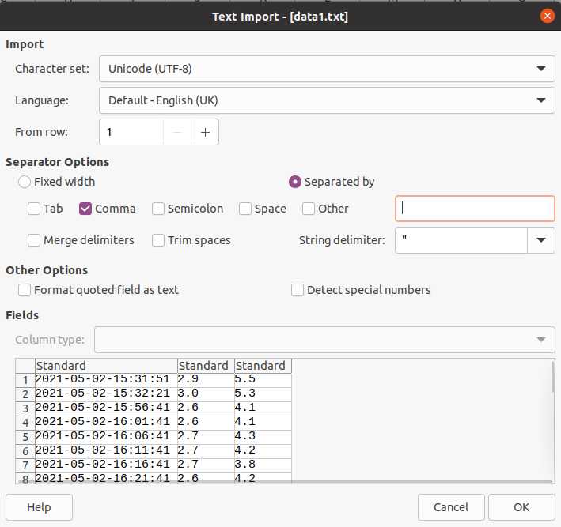

This is what your columns will look like once they have been imported
You can use the other separator options including – and : to add further columns. Consider how this might be helpful if you were interested in plotting the time of the measurements against the concentration of particles.

Import Dialogue Box options

Character Set
Specifies the character set to be used in the imported file.

Language
Determines how the number strings are imported.
If Language is set to Default (for CSV import) or Automatic (for HTML import), Calc will use the globally set language. If Language is set to a specific language, that language will be used when importing numbers.
When importing an HTML document, the Language selection can conflict with the global HTML option Use 'English (USA)' locale for numbers. The global HTML option is effective only when the Automatic language option is selected. If you select a specific language in the HTML Import Options dialogue, the global HTML option is ignored.

From Row
Specifies the row where you want to start the import. The rows are visible in the preview window at the bottom of the dialogue.

Separator Options
Specifies whether your data uses separators or fixed widths as delimiters.

Fixed width
Separates fixed-width data (equal number of characters) into columns. Click on the ruler in the preview window to set the width.

Separated by
Select the separator used in your data.

Tab
Separates data delimited by tabs into columns.

Semicolon
Separates data delimited by semicolons into columns.

Comma
Separates data delimited by commas into columns.

Space
Separates data delimited by spaces into columns.

Other
Separates data into columns using the custom separator that you specify. Note: The custom separator must also be contained in your data.

Merge delimiters
Combines consecutive delimiters and removes blank data fields.

Trim spaces
Removes starting and trailing spaces from data fields.

String delimiter
Select a character to delimit text data. You can can also enter a character in the text box.

Other options
Sets some other import options.

Format quoted field as text
When this option is enabled, fields or cells whose values are quoted in their entirety (the first and last characters of the value equal the text delimiter) are imported as text.

Detect special numbers
When this option is enabled, Calc will automatically detect all number formats, including special number formats such as dates, time, and scientific notation.
The selected language influences how such special numbers are detected, since different languages and regions many have different conventions for such special numbers.
When this option is disabled, Calc will detect and convert only decimal numbers. The rest, including numbers formatted in scientific notation, will be imported as text. A decimal number string can have digits 0-9, thousands separators, and a decimal separator. Thousands separators and decimal separators may vary with the selected language and region.

Skip empty cells
When this option is enabled, Calc preserves previous content of cells when pasting empty ones. Otherwise, Calc deletes content of previous cells.
In Text to Columns conversion, if cell content begins with a separator and this option is disabled, then first column will be emptied.

Fields
Shows how your data will look when it is separated into columns.

Column type
Choose a column in the preview window and select the data type to be applied the imported data. You can select one of the following options:
Type | Function
Standard | LibreOffice determines the type.
Text | Imported data are treated as text.
Date (DMY) | Applies a date format (Day, Month, Year) to the imported data in a column.
Date (MDY) | Applies a date format (Month, Day, Year) to the imported data in a column.
Date (YMD) | Applies a date format (Year, Month, Day) to the imported data in a column.
US English | Numbers formatted in US English are searched for and included regardless of the system language. A number format is not applied. If there are no US English entries, the Standard format is applied.
Hide | The data in the column are not imported.

If you selected one of the date formats (DMY), (MDY), or (YMD) and you enter numbers without date delimiters, the numbers are interpreted as follows:
Number of characters | Date format
6 | Two characters each are taken for day, month, and year in the selected order.
8 | Four characters are taken for the year, two each for month and day, in the selected order.
5 or 7 | As with 6 or 8 characters, but the first part of the sequence has one character less. This will suppress a leading zero for month and day.

Note: If you want to include the leading zero in the data you import, in telephone numbers for example, apply the "Text" format to the column.

Preview
Shows how the imported text will look after it is separated into columns. To apply a format to a column when it is imported, click a column and select a Column type. When you select a Column type, the column heading displays the applied format.
If you want to use a fixed width to separate the imported data into columns, click in the ruler to set the width boundaries.

Naming Cell Ranges
Before making a start on this we need to know the allowed names
Names in Calc can contain letters, numeric characters, and some special characters. Names must start with a letter or an underline character.
Allowed special characters:
underline (_)
dot (.) - allowed within a name, but not as first or last character
blank ( ) - allowed within a name, but not as first or last character, and not for a cell range
Names must not be the same as cell references. For example, the name A1 is invalid because A1 is a cell reference to the top left cell.
Names must not start with the letters C or R followed by a number; also single characters C and R are not allowed as names. This conflicts with the ADDRESS function.
Names for cell ranges must not include blanks. Blanks are allowed within names for single cells, sheets and documents.
A good way of making the references to cells and cell ranges in formulas legible is to give the ranges names. For example, you can name the range A1:B2 Start. You can then write a formula such as "=SUM(Start)". Even after you insert or delete rows or columns, LibreOffice still correctly assigns the ranges identified by name. Range names must not contain any spaces.
For example, it is much easier to read a formula for sales tax if you can write:
"= Amount * Tax_rate" instead of "= A5 * B12". In this case, you would name cell A5 "Amount" and cell B12 "Tax_rate."

Use the Manage Names dialogue to define names for formulas or parts of formulas you need more often. In order to specify range names,
- Select a cell or range of cells, then choose Name Box drop-down Manage Names dialogue appears.
- Click Add. Type the name of the selected area in the Name field. The newly defined name appears in the list below. Click OK to close the dialogue.
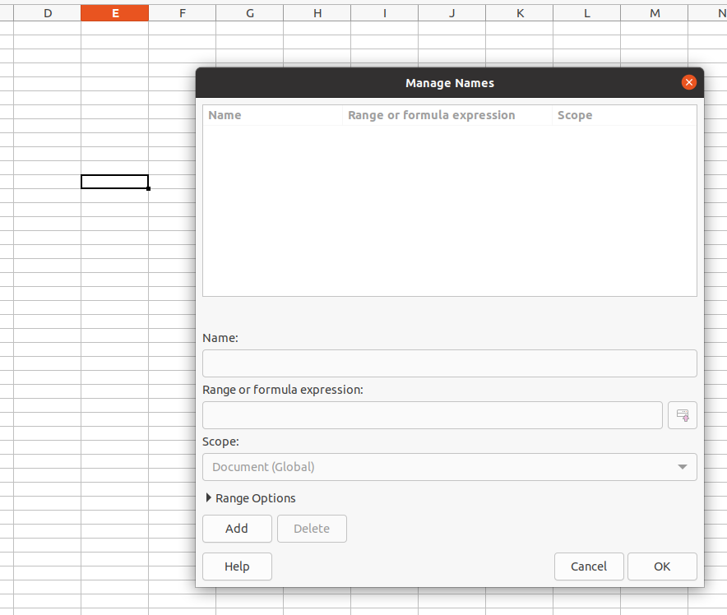

You can also name other cell ranges in this dialogue by entering the name in the field and then selecting the respective cells.
If you type the name in a formula, after the first few characters entered you will see the entire name as a tip.
- Press the Enter key in order to accept the name from the tip.
- If more than one name starts with the same characters, you can scroll through all the names using the Tab key.

Naming Ranges within Formulas
You can use cells with text to refer to the rows or to the columns that contain the cells.
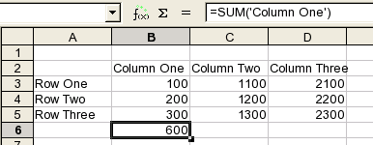
In the example spreadsheet, you can use the string 'Column One' in a formula to refer to the cell range B3 to B5, or 'Column Two' for the cell range C2 to C5. You can also use 'Row One' for the cell range B3 to D3, or 'Row Two' for the cell range B4 to D4. The result of a formula that uses a cell name, for example, SUM('Column One'), is 600.
This function is active by default. To turn this function off, choose Tools - Options - LibreOffice Calc - Calculate and clear the Automatically find column and row labels check box.

Navigating Through Workbooks Using Named Ranges

Creating Named Ranges Automatically Based on Cell Values

Deleting Named Cells/Ranges

Creating Subtotals

Removing Subtotals

Templates
• Using Templates
• Creating Templates
• Opening and Editing Templates

Formatting and Display Techniques
• Formatting Tables
• Formatting Tables Using Table Styles
• Formatting Cell Ranges Using Conditional Formatting
• Creating Custom Number Formats
• Freezing the Top Row
• Freezing the First Column
• Freezing the Top Row and the First Column Simultaneously
• Hiding and Un-Hiding Rows
• Hiding and Un-Hiding Columns
• Hiding and Un-Hiding Worksheets

Sorting and Querying Data
• Sorting Internal Calc Databases
• Custom Sort Options
• Using AutoFilter to Query Data
• Multiple Queries
• Removing Queries
• Top 10 AutoFilter
• Filtering Unique Records
• Advanced Filter

Linking and Consolidation
• Linking Individual Cells within a Worksheet
• Linking Charts to Data within a Worksheet
• Linking a Cell Range on One Worksheet to Another Worksheet
• Linking Data From One Workbook to Another
• Linking Data on One Worksheet to a Chart in Another Worksheet
• Linking a Chart From one Workbook to Another
• Copying Data from Calc into a Word Document
• Linking a Chart from Calc into a Word Document
• Consolidating Data Over Several Worksheets or Worksheet Pages

Chart Formatting Techniques
• Changing the Angle of a Pie Chart Slice
• Formatting the Chart Axis Fonts
• Formatting the Chart Axis Scales
• Formatting the Chart Axis Txt Orientation
• Creating and Positioning a Chart Title
• Re-Positioning a Chart legend
• Re-Positioning Chart data labels
• Exploding the Segments within a Pie Chart
• Deleting a Data Series within a Chart
• Adding a Data Series to a Chart
• Modifying the Chart Type for a Defined Data Series
• Widening the Gap Between Columns/Bars within a 2D Chart
• Inserting an Image into a 2D Chart (As a Background)
• Inserting an Image into a 2D Chart (To Format a Column or Bar of Data)

Database functions
Syntax: Dfunction(Database_arr , Field_str|num , Criteria_arr)
Where Dfunction is one of the following:
- DAVERAGE
- DCOUNT
- DCOUNTA
- DGET
- DMAX
- DMIN
- DPRODUCT
- DSTDEV
- DSTDEVP
- DSUM
- DVAR
- DVARP
Type: Database
Database functions are particularly handy when Google Sheets is used to maintain structured data, like a database. Each database function, Dfunction, computes the corresponding function on a subset of a cell range regarded as a database table.
Database functions take three arguments:
- Database_arr is a range, embedded array or array generated by an array expression that is structured so that each row after Row 1 is a database record, and each column is a database field. Row 1 contains the labels for each field.
- Field_str|num indicates which column (field) contains the values to be averaged. This can be expressed as either the field name (text string) or the column number, where the left-most column would be represented as 1.
- Criteria_arr is a range, embedded array or array generated by an array expression that is structured such that the first row contains the field name(s) to which the criterion (criteria) will be applied, and subsequent rows contain the conditional test(s).
The first row in Criteria specifies field names. Every other row in Criteria represents a filter, which is a set of restrictions on the corresponding fields. Restrictions are described using Query-by-Example notation, and can include a value to match or a comparison operator followed by a comparison value.
Examples of restrictions are: "Chocolate", "42", ">= 42", "<> 42". An empty cell means no restriction on the corresponding field.
A filter matches a database row if all the filter restrictions (the restrictions in the filter's row) are met. A database row (record) satisfies Criteria if and only if at least one filter matches it. A field name may appear more than once in the Criteria range to allow multiple restrictions that apply simultaneously (for example, temperature >= 65 and temperature <= 82).
DGET is the only database function that doesn't aggregate values. DGET returns the value of the field specified in the second argument (similarly to a VLOOKUP) only when exactly one record matches Criteria; otherwise, it returns an error indicating no matches or multiple matches

Example Data:
The following data will be used in some of the function description examples:
The range A1:E10 lists the children invited to {a school event?}Joe's birthday party. The following information is given for each entry: column A shows the name, B the grade, then age in years, distance to school in metres and weight in kilograms.
 | A | B | C | D | E
1 | Name | Grade | Age | Distance to School | Weight
2 | Andy | 3 | 9 | 150 | 40
3 | Betty | 4 | 10 | 1000 | 42
4 | Charles | 3 | 10 | 300 | 51
5 | Daniel | 5 | 11 | 1200 | 48
6 | Eva | 2 | 8 | 650 | 33
7 | Frank | 2 | 7 | 300 | 42
8 | Greta | 1 | 7 | 200 | 36
9 | Harry | 3 | 9 | 1200 | 44
10 | Irene | 2 | 8 | 1000 | 42
11
12
13 | Name | Grade | Age | Distance to School | Weight
14 |  |  |  | >600
15
16 | DCOUNT | 5

The formula in cell B16 is =DCOUNT(A1:E10;D1;A13:E14)

Database Function Parameters:
The following items are the parameter definitions for all database functions:
Database is the cell range defining the database in this case A1 to E10 or A1:E10.
DatabaseField specifies the column where the function operates on after the search criteria of the first parameter is applied and the data rows are selected. D1 in this case. It is not related to the search criteria itself. For the DatabaseField parameter you can enter a reference to a header cell or a number to specify the column within the Database area, starting with 1. To reference a column by means of the literal column header name, place quotation marks around the header name.
SearchCriteria is the cell range containing search criteria in this case A1 to E14 or if you prefer A1:E14. This range is usually created by copying the Header Row to below the table. Notice the criteria go in the row below. In this case it needs only 1 row, but in some cases this can be several rows.
If you write several criteria in one row they are connected by logical AND. If you write the criteria in different rows they are connected by logical OR. Empty cells in the search criteria range will be ignored.
It is easy to add multiple criteria this way in order to answer what if questions.
Choose Tools - Options - LibreOffice Calc - Calculate to define how LibreOffice Calc acts when searching for identical entries.
See also the Wiki page about Conditional Counting and Summation.

DAVERAGE
DAVERAGE returns the average of the values of all cells (fields) in all rows (database records) that match the specified search criteria.
The search supports regular expressions. You can enter "all.*", for example to find the first location of "all" followed by any characters. If you want to search for a text that is also a regular expression, you must precede every character with a "\" character. You can switch the automatic evaluation of regular expression on and off in Tools - Options - LibreOffice Calc - Calculate.

Syntax
DAVERAGE(Database; DatabaseField; SearchCriteria)
For the DatabaseField parameter you can enter a reference to a header cell or a number to specify the column within the Database area, starting with 1. To reference a column by means of the literal column header name, place quotation marks around the header name.

Example
To find the average weight of all children of the same age in the above example (scroll up, please), enter the following formula in B16:
=DAVERAGE(A1:E10;"Weight";A13:E14)
In row 14, under Age, enter 7, 8, 9, and so on, one after the other. The average weight of all children of the same age will appear.

DCOUNT
DCOUNT counts the number of rows (records) in a database that match the specified search criteria and contain numeric values in the DatabaseField column.
The search supports regular expressions. You can enter "all.*", for example to find the first location of "all" followed by any characters. If you want to search for a text that is also a regular expression, you must precede every character with a "\" character. You can switch the automatic evaluation of regular expression on and off in - LibreOffice Calc - Calculate.

Syntax
DCOUNT(Database; [DatabaseField]; SearchCriteria)
If the DatabaseField argument is omitted, DCOUNT returns the count of all records that satisfy Criteria. For the DatabaseField parameter you can enter a reference to a header cell or a number to specify the column within the Database area, starting with 1. To reference a column by means of the literal column header name, place quotation marks around the header name.

Example
In the example above (scroll up, please), we want to know how many children have to travel more than 600 meters to school. The result is to be stored in cell B16. Set the cursor in cell B16. Enter the formula =DCOUNT(A1:E10;D1;A13:E14) in B16. The Function Wizard helps you to input ranges.
Database is the range of data to be evaluated, including its headers: in this case A1:E10. DatabaseField specifies the column for the search criteria: in this case, the column with the numeric distance values. SearchCriteria is the range where you can enter the search parameters: in this case, A13:E14.
To learn how many children in second grade are over 7 years of age, delete the entry >600 in cell D14 and enter 2 in cell B14 under Grade and enter >7 in cell C14 to the right. The result is 2. Two children are in second grade and over 7 years of age. As both criteria are in the same row, they are connected by AND.

DCOUNTA
DCOUNTA counts the number of rows (records) in a database that match the specified search conditions and contain numeric or alphanumeric values.
The search supports regular expressions. You can enter "all.*", for example to find the first location of "all" followed by any characters. If you want to search for a text that is also a regular expression, you must precede every character with a "\" character. You can switch the automatic evaluation of regular expression on and off in - LibreOffice Calc - Calculate.

Syntax
DCOUNTA(Database; [DatabaseField]; SearchCriteria)
If the DatabaseField argument is omitted, DCOUNTA returns the count of all records that satisfy Criteria. For the DatabaseField parameter you can enter a reference to a header cell or a number to specify the column within the Database area, starting with 1. To reference a column by means of the literal column header name, place quotation marks around the header name.

Example
In the example above (scroll up, please), you can search for the number of children whose names start with an E or a subsequent letter. Edit the formula in B16 to read =DCOUNTA(A1:E10;"Name";A13:E14). Delete the old search criteria and enter >=E under Name in field A14. The result is 5. If you now delete all number values for Greta in row 8, the result changes to 4. Row 8 is no longer included in the count because it does not contain any values. The name Greta is text, not a value. Note that the DatabaseField parameter must point to a column that can contain values.

DGET
DGET returns the contents of the referenced cell in a database which matches the specified search criteria. In case of an error, the function returns either #VALUE! for no row found, or Err502 for more than one cell found.
The search supports regular expressions. You can enter "all.*", for example to find the first location of "all" followed by any characters. If you want to search for a text that is also a regular expression, you must precede every character with a "\" character. You can switch the automatic evaluation of regular expression on and off in - LibreOffice Calc - Calculate.

Syntax
DGET(Database; DatabaseField; SearchCriteria)
For the DatabaseField parameter you can enter a reference to a header cell or a number to specify the column within the Database area, starting with 1. To reference a column by means of the literal column header name, place quotation marks around the header name.

Example
In the above example (scroll up, please), we want to determine which grade that a child, whose name was entered in cell A14, is in. The formula is entered in cell B16 and differs slightly from the earlier examples because only one column (one database field) can be entered for DatabaseField. Enter the following formula:
=DGET(A1:E10;"Grade";A13:E14)
Enter the name Frank in A14 and you will see the result 2. Frank is in second grade. Enter "Age" instead of "Grade" and you will get Frank's age.
Or enter the value 11 in cell C14 only and delete the other entries in this row. Edit the formula in B16 as follows:
=DGET(A1:E10;"Name";A13:E14)
Instead of the grade, the name is queried. The answer appears at once: Daniel is the only child aged 11.

DMAX
DMAX returns the maximum content of a cell (field) in a database (all records) that matches the specified search conditions.
The search supports regular expressions. You can enter "all.*", for example to find the first location of "all" followed by any characters. If you want to search for a text that is also a regular expression, you must precede every character with a "\" character. You can switch the automatic evaluation of regular expression on and off in - LibreOffice Calc - Calculate.

Syntax
DMAX(Database; DatabaseField; SearchCriteria)
For the DatabaseField parameter you can enter a reference to a header cell or a number to specify the column within the Database area, starting with 1. To reference a column by means of the literal column header name, place quotation marks around the header name.

Example
To find out how much the heaviest child in each grade weighed in the above example (scroll up, please), enter the following formula in B16:
=DMAX(A1:E10;"Weight";A13:E14)
Under Grade, enter 1, 2, 3, and so on, one after the other. After entering a grade number, the weight of the heaviest child in that grade will appear.

DMIN
DMIN returns the minimum content of a cell (field) in a database that matches the specified search criteria.
The search supports regular expressions. You can enter "all.*", for example to find the first location of "all" followed by any characters. If you want to search for a text that is also a regular expression, you must precede every character with a "\" character. You can switch the automatic evaluation of regular expression on and off in - LibreOffice Calc - Calculate.

Syntax
DMIN(Database; DatabaseField; SearchCriteria)
For the DatabaseField parameter you can enter a reference to a header cell or a number to specify the column within the Database area, starting with 1. To reference a column by means of the literal column header name, place quotation marks around the header name.

Example
To find the shortest distance to school for the children in each grade in the above example (scroll up, please), enter the following formula in B16:
=DMIN(A1:E10;"Distance to School";A13:E14)
In row 14, under Grade, enter 1, 2, 3, and so on, one after the other. The shortest distance to school for each grade will appear.

DPRODUCT
DPRODUCT multiplies all cells of a data range for which each cell content matches the search criteria.
The search supports regular expressions. You can enter "all.*", for example to find the first location of "all" followed by any characters. If you want to search for a text that is also a regular expression, you must precede every character with a "\" character. You can switch the automatic evaluation of regular expression on and off in - LibreOffice Calc - Calculate.

Syntax
DPRODUCT(Database; DatabaseField; SearchCriteria)
For the DatabaseField parameter you can enter a reference to a header cell or a number to specify the column within the Database area, starting with 1. To reference a column by means of the literal column header name, place quotation marks around the header name.

Example
With the birthday party example above (scroll up, please), there is no meaningful application of this function.

DSTDEV
DSTDEV calculates the standard deviation of a population based on a sample, using the numbers in a database column that match the given conditions. The records are treated as a sample of data. That means that the children in the example represent a cross section of all children. Note that a representative result can not be obtained from a sample of less than one thousand.
The search supports regular expressions. You can enter "all.*", for example to find the first location of "all" followed by any characters. If you want to search for a text that is also a regular expression, you must precede every character with a "\" character. You can switch the automatic evaluation of regular expression on and off in - LibreOffice Calc - Calculate.

Syntax
DSTDEV(Database; DatabaseField; SearchCriteria)
For the DatabaseField parameter you can enter a reference to a header cell or a number to specify the column within the Database area, starting with 1. To reference a column by means of the literal column header name, place quotation marks around the header name.

Example
To find the standard deviation of the weight for all children of the same age in the example (scroll up, please), enter the following formula in B16:
=DSTDEV(A1:E10;"Weight";A13:E14)
In row 14, under Age, enter 7, 8, 9, and so on, one after the other. The result shown is the standard deviation of the weight of all children of this age.

DSTDEVP
DSTDEVP calculates the standard deviation of a population based on all cells of a data range which match the search criteria. The records from the example are treated as the whole population.
The search supports regular expressions. You can enter "all.*", for example to find the first location of "all" followed by any characters. If you want to search for a text that is also a regular expression, you must precede every character with a "\" character. You can switch the automatic evaluation of regular expression on and off in - LibreOffice Calc - Calculate.

Syntax
DSTDEVP(Database; DatabaseField; SearchCriteria)
For the DatabaseField parameter you can enter a reference to a header cell or a number to specify the column within the Database area, starting with 1. To reference a column by means of the literal column header name, place quotation marks around the header name.

Example
To find the standard deviation of the weight for all children of the same age at Joe's birthday party (scroll up, please), enter the following formula in B16:
=DSTDEVP(A1:E10;"Weight";A13:E14)
In row 14, under Age, enter 7, 8, 9, and so on, one after the other. The result is the standard deviation of the weight for all same-aged children whose weight was checked.

DSUM
DSUM returns the total of all cells in a database field in all rows (records) that match the specified search criteria.
The search supports regular expressions. You can enter "all.*", for example to find the first location of "all" followed by any characters. If you want to search for a text that is also a regular expression, you must precede every character with a "\" character. You can switch the automatic evaluation of regular expression on and off in - LibreOffice Calc - Calculate.

Syntax
DSUM(Database; DatabaseField; SearchCriteria)
For the DatabaseField parameter you can enter a reference to a header cell or a number to specify the column within the Database area, starting with 1. To reference a column by means of the literal column header name, place quotation marks around the header name.

Example
To find the length of the combined distance to school of all children at Joe's birthday party (scroll up, please) who are in second grade, enter the following formula in B16:
=DSUM(A1:E10;"Distance to School";A13:E14)
Enter 2 in row 14 under Grade. The sum (1950) of the distances to school of all the children who are in second grade is displayed.

DVAR
DVAR returns the variance of all cells of a database field in all records that match the specified search criteria. The records from the example are treated as a sample of data. A representative result cannot be obtained from a sample population of less than one thousand.
The search supports regular expressions. You can enter "all.*", for example to find the first location of "all" followed by any characters. If you want to search for a text that is also a regular expression, you must precede every character with a "\" character. You can switch the automatic evaluation of regular expression on and off in - LibreOffice Calc - Calculate.

Syntax
DVAR(Database; DatabaseField; SearchCriteria)
For the DatabaseField parameter you can enter a reference to a header cell or a number to specify the column within the Database area, starting with 1. To reference a column by means of the literal column header name, place quotation marks around the header name.

Example
To find the variance of the weight of all children of the same age of the above example (scroll up, please), enter the following formula in B16:
=DVAR(A1:E10;"Weight";A13:E14)
In row 14, under Age, enter 7, 8, 9, and so on, one after the other. You will see as a result the variance of the weight values for all children of this age.

DVARP
DVARP calculates the variance of all cell values in a database field in all records that match the specified search criteria. The records are from the example are treated as an entire population.
The search supports regular expressions. You can enter "all.*", for example to find the first location of "all" followed by any characters. If you want to search for a text that is also a regular expression, you must precede every character with a "\" character. You can switch the automatic evaluation of regular expression on and off in - LibreOffice Calc - Calculate.

Syntax
DVARP(Database; DatabaseField; SearchCriteria)
For the DatabaseField parameter you can enter a reference to a header cell or a number to specify the column within the Database area, starting with 1. To reference a column by means of the literal column header name, place quotation marks around the header name.

Example
To find the variance of the weight for all children of the same age at Joe's birthday party (scroll up, please), enter the following formula in B16:
=DVARP(A1:E10;"Weight";A13:E14)
In row 14, under Age, enter 7, 8, 9, and so on, one after the other. The variance of the weight values for all children of this age attending Joe's birthday party will appear.

Understanding and calculating variance
Published on September 24, 2020 by Pritha Bhandari. Revised on October 12, 2020.
The variance is a measure of variability. It is calculated by taking the average of squared deviations from the mean.
Variance tells you the degree of spread in your data set. The more spread the data, the larger the variance is in relation to the mean.

Variance vs standard deviation
The standard deviation is derived from variance and tells you, on average, how far each value lies from the mean. It’s the square root of variance.
Both measures reflect variability in a distribution, but their units differ:
- Standard deviation is expressed in the same units as the original values (e.g., meters).
- Variance is expressed in much larger units (e.g., meters squared)
Since the units of variance are much larger than those of a typical value of a data set, it’s harder to interpret the variance number intuitively. That’s why standard deviation is often preferred as a main measure of variability.
However, the variance is more informative about variability than the standard deviation, and it’s used in making statistical inferences.

Population vs sample variance
Different formulas are used for calculating variance depending on whether you have data from a whole population or a sample.

Population variance
When you have collected data from every member of the population that you’re interested in, you can get an exact value for population variance.
The population variance formula looks like this:

Formula | Explanation
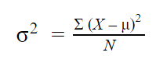 | - σ2 = population variance  - Σ = sum of…  - Χ = each value  - μ = population mean  - Ν = number of values in the population

Sample variance
When you collect data from a sample, the sample variance is used to make estimates or inferences about the population variance.
The sample variance formula looks like this:
Formula | Explanation
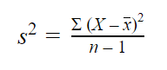 | - s2 = sample variance  - Σ = sum of…  - Χ = each value  - x̄ = sample mean  - n = number of values in the sample
With samples, we use n – 1 in the formula because using n would give us a biased estimate that consistently underestimates variability. The sample variance would tend to be lower than the real variance of the population.
Reducing the sample n to n – 1 makes the variance artificially large, giving you an unbiased estimate of variability: it is better to overestimate rather than underestimate variability in samples.
It’s important to note that doing the same thing with the standard deviation formulas doesn’t lead to completely unbiased estimates. Since a square root isn’t a linear operation, like addition or subtraction, the unbiasedness of the sample variance formula doesn’t carry over the sample standard deviation formula.

Steps for calculating the variance
The variance is usually calculated automatically by whichever software you use for your statistical analysis. But you can also calculate it by hand to better understand how the formula works.
There are five main steps for finding the variance by hand. We’ll use a small data set of 6 scores to walk through the steps.
Data set
46 | 69 | 32 | 60 | 52 | 41

Step 1: Find the mean
To find the mean, add up all the scores, then divide them by the number of scores.
Mean (x̅)
x̅ = (46 + 69 + 32 + 60 + 52 + 41) ÷ 6 = 50

Step 2: Find each score’s deviation from the mean
Subtract the mean from each score to get the deviations from the mean.
Since x̅ = 50, take away 50 from each score.
Score | Deviation from the mean
46 | 46 – 50 = -4
69 | 69 – 50 = 19
32 | 32 – 50 = -18
60 | 60 – 50 = 10
52 | 52 – 50 = 2
41 | 41 – 50 = -9

Step 3: Square each deviation from the mean
Multiply each deviation from the mean by itself. This will result in positive numbers.
Squared deviations from the mean
(-4)2 = 4 × 4 = 16
192 = 19 × 19 = 361
(-18)2 = -18 × -18 = 324
102 = 10 × 10 = 100
22 = 2 × 2 = 4
(-9)2 = -9 × -9 = 81

Step 4: Find the sum of squares
Add up all of the squared deviations. This is called the sum of squares.
Sum of squares
16 + 361 + 324 + 100 + 4 + 81 = 886

Step 5: Divide the sum of squares by n – 1 or N
Divide the sum of the squares by n – 1 (for a sample) or N (for a population).
Since we’re working with a sample, we’ll use n – 1, where n = 6.
Variance
886 ÷ (6 – 1) = 886 ÷ 5 = 177.2

Why does variance matter?
Variance matters for two main reasons:
- Parametric statistical tests are sensitive to variance.
- Comparing the variance of samples helps you assess group differences.

Homogeneity of variance in statistical tests
Variance is important to consider before performing parametric tests. These tests require equal or similar variances, also called homogeneity of variance or homoscedasticity, when comparing different samples.
Uneven variances between samples result in biased and skewed test results. If you have uneven variances across samples, non-parametric tests are more appropriate.

Using variance to assess group differences
Statistical tests like variance tests or the analysis of variance (ANOVA) use sample variance to assess group differences. They use the variances of the samples to assess whether the populations they come from differ from each other.
As an education researcher, you want to test the hypothesis that different frequencies of quizzes lead to different final scores of college students. You collect the final scores from three groups with 20 students each that had quizzes frequently, infrequently, or rarely over a semester.
- Sample A: Once a week
- Sample B: Once every 3 weeks
- Sample C: Once every 6 weeks
To assess group differences, you perform an ANOVA.
The main idea behind an ANOVA is to compare the variances between groups and variances within groups to see whether the results are best explained by the group differences or by individual differences.
If there’s higher between-group variance relative to within-group variance, then the groups are likely to be different as a result of your treatment. If not, then the results may come from individual differences of sample members instead.

VLOOKUP function
The VLOOKUP function (short for Vertical LOOKUP) is a built-in Calc function that is designed to work with data that is organized into columns. For a specified value, the function finds (or looks up) the value in one column of data, and returns the corresponding value from another column. Once you understand how VLOOKUP works and how to use it you will be able to create more sophisticated spreadsheets and further automate your work.

VLOOKUP example
The VLOOKUP function is best explained using an example. In the spreadsheet below we calculate the Invoice Total as the sum of the Order Total plus the Shipping Cost.

Shipment Type | Price | Delivery Days
Free | 0 | 7
Standard | 5 | 3
Premium | 10 | 1
 | Order total | 300
 | Shipping Type | Standard
 | Shipping Cost | 5
 | Invoice Total | 305

Instead of manually typing the Shipping Cost every time, VLOOKUP enables you to find the cost from the table above using the Shipping Type information ("Premium" in our example). You can probably already see in our example, at a glance, what is the cost of shipping, but on a more complex spreadsheet this information might be out of view, or even on another sheet. It is also shown by the example that with VLOOKUP we can refer to properties or values of a category simply by its name.

Using VLOOKUP
Lets insert the VLOOKUP formula into the Shipping Cost cell (C9). VLOOKUP has a lot of arguments therefore it is best to use the function wizard . Select the cell C9 where the VLOOKUP function will be inserted. On the Function Wizard window select the Spreadsheet function category and choose the VLOOKUP function from the bottom of the list. Now you have to fill the four arguments that VLOOKUP requires.

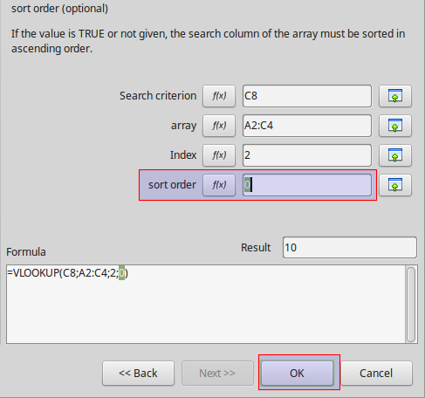

Search criterion. This is the value that is searched for in the first column of the data table. In our example we are looking for the "shipping type" contained in cell C8.

Search criterion. This is the value that is searched for in the first column of the data table. In our example we are looking for the "shipping type" contained in cell C8.
Array. Now you must tell VLOOKUP the array where to look for the search criterion. In our example the array is the cell range A2:C4. VLOOKUP will search for the criterion in the first column of the array. One must ask why we give the array and not just the first column? The answer is because VLOOUKP needs the array not only to search but to return results from the other columns.
Index. The third argument is the column number from which the value will be returned. The first column has index 1, column 2, etc. In our example, we try to find the shipping cost contained in the second column.
Sort order. The last argument is optional but you are advised to use 0 or FALSE. When the sort order is 0 and a search term is not found, VLOOKUP returns an error message. If you skip this argument, the default value will be 1 or TRUE. In this case, VLOOKUP will always return the result of the last row even if the search does not match the term. This can easily lead to bugs in your spreadsheet if you do not know exactly how VLOOKUP works.
When you finish and click OK the formula result will be displayed in the cell with the Shipping Cost.

Order total | 300
Shipping Type | Premium
Shipping Cost | 10
Invoice Total | 310

Now if you change the Shipping Type to "Standard" the Shipping Cost automatically calculates to the value of 5

Order total | 300
Shipping Type | Standard
Shipping Cost | 5
Invoice Total | 305

However if you insert a value that is not found on the array VLOOKUP will output an error. However, if you have assigned a sort order of 1 then the last ranked result will be returned.

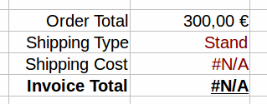

How VLOOKUP works
Now that you have seen an example we can summarize how VLOOKUP function works.
- Look for a value (for example "Premium") specified in the search criterion.
- Define the a range that contains the column to look for and the columns to return results in the array argument. VLOOKUP will always search the first column in this range.
- Now return the value that is in the same row with the matching result and in the column specified by the column index.
- Use sort order 0, except when you have very large arrays and the first column is sorted.
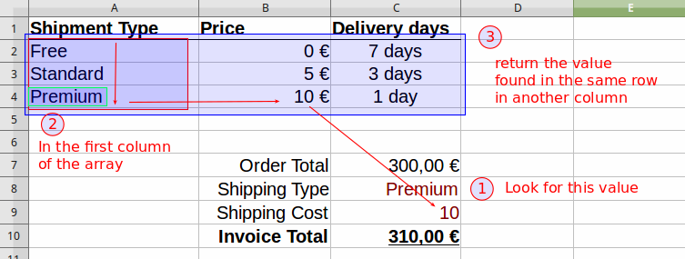

Protection and Security
• Specifying a Password for Opening a Workbook
• Using the 'Read Only Recommended' Option

