

LibreOffice Base
Date Created October 2021
Reviewed
Version

Description

Typographic Conventions
Style | Description | Example
Text Body  Liberation Serif 10 | Normal body text | This is normal text
Key (Light Teal 4) | Keyboard shortcut | Press Ctrl + c to copy object
sudo su | Commands that should be run by theuser | sudo apt update
menu | Menu Item | File > save to acess the save feature

Advantages of LibreOffice
Here are some of the advantages of LibreOffice over other office suites:
- •No licensing fees. LibreOffice is free for anyone to use and distribute at no cost. Many features that are available as extra cost add-ins in other office suites (like PDF export) are free with LibreOffice. There are no hidden charges now or in the future.
- •Open source. You can distribute, copy, and modify the software as much as you wish, in accordance with the LibreOffice Open Source licenses.
- •Cross-platform. LibreOffice runs on several hardware architectures and under multiple operating systems, such as Microsoft Windows, Mac OS X and Linux.
- •Extensive language support. The LibreOffice user interface, including spelling, hyphenation, and thesaurus dictionaries, is available in over 100 languages and dialects. LibreOffice also provides support for both Complex Text Layout (CTL) and Right to Left (RTL) layout languages (such as Urdu, Hebrew, and Arabic).
- •Consistent user interface. All the components have a similar “look and feel,” making them easy to use and master.
- •Integration. The components of LibreOffice are well integrated with one another.
- –All the components share a common spelling checker and other tools, which are used consistently across the suite. For example, the drawing tools available in Writer are also found in Calc, with similar but enhanced versions in Impress and Draw.
- –You do not need to know which application was used to create a particular file. For example, you can open a Draw file from Writer.
- •Granularity. Usually, if you change an option, it affects all components. However, LibreOffice options can be set at a component level or even at document level.
- •File compatibility. In addition to its native OpenDocument formats, LibreOffice includes support for opening and saving files in many common formats including Microsoft Office, HTML, XML, WordPerfect, Lotus 1-2-3, and PDF.
- •No vendor lock-in. LibreOffice uses OpenDocument, an XML (eXtensible Markup Language) file format developed as an industry standard by OASIS (Organization for the Advancement of Structured Information Standards). These files can easily be unzipped and read by any text editor, and their framework is open and published.
- •You have a voice. Enhancements, software fixes, and release dates are community-driven. You can join the community and affect the course of the product you use.
You can read more about LibreOffice and The Document Foundation on their websites at http://www.libreoffice.org/ and http://www.documentfoundation.org/.

Introduction
In everyday office operation, spreadsheets are regularly used to aggregate sets of data and to perform some kind of analyses on them. As the data in a spreadsheet is laid out in a table view, plainly visible and able to be edited or added to, many users ask why they should use a database instead of a spreadsheet. This handbook explains the differences between the two, beginning with a short section on what can be done with a database.

Base provides tools for day-to-day database work within a simple interface. It can create and edit forms, reports, queries, tables, views, and relations, so that managing a relational database is much the same as in other popular database applications. Base provides many new features, such as the ability to analyse and edit relationships from a diagram view. Base incorporates two relational database engines, HSQLDB and PostgreSQL. It can also use dBASE, Microsoft Access, MySQL, or Oracle, or any ODBC compliant or JDBC compliant database. Base also provides support for a subset of ANSI-92 SQL.

Diagram of a base database
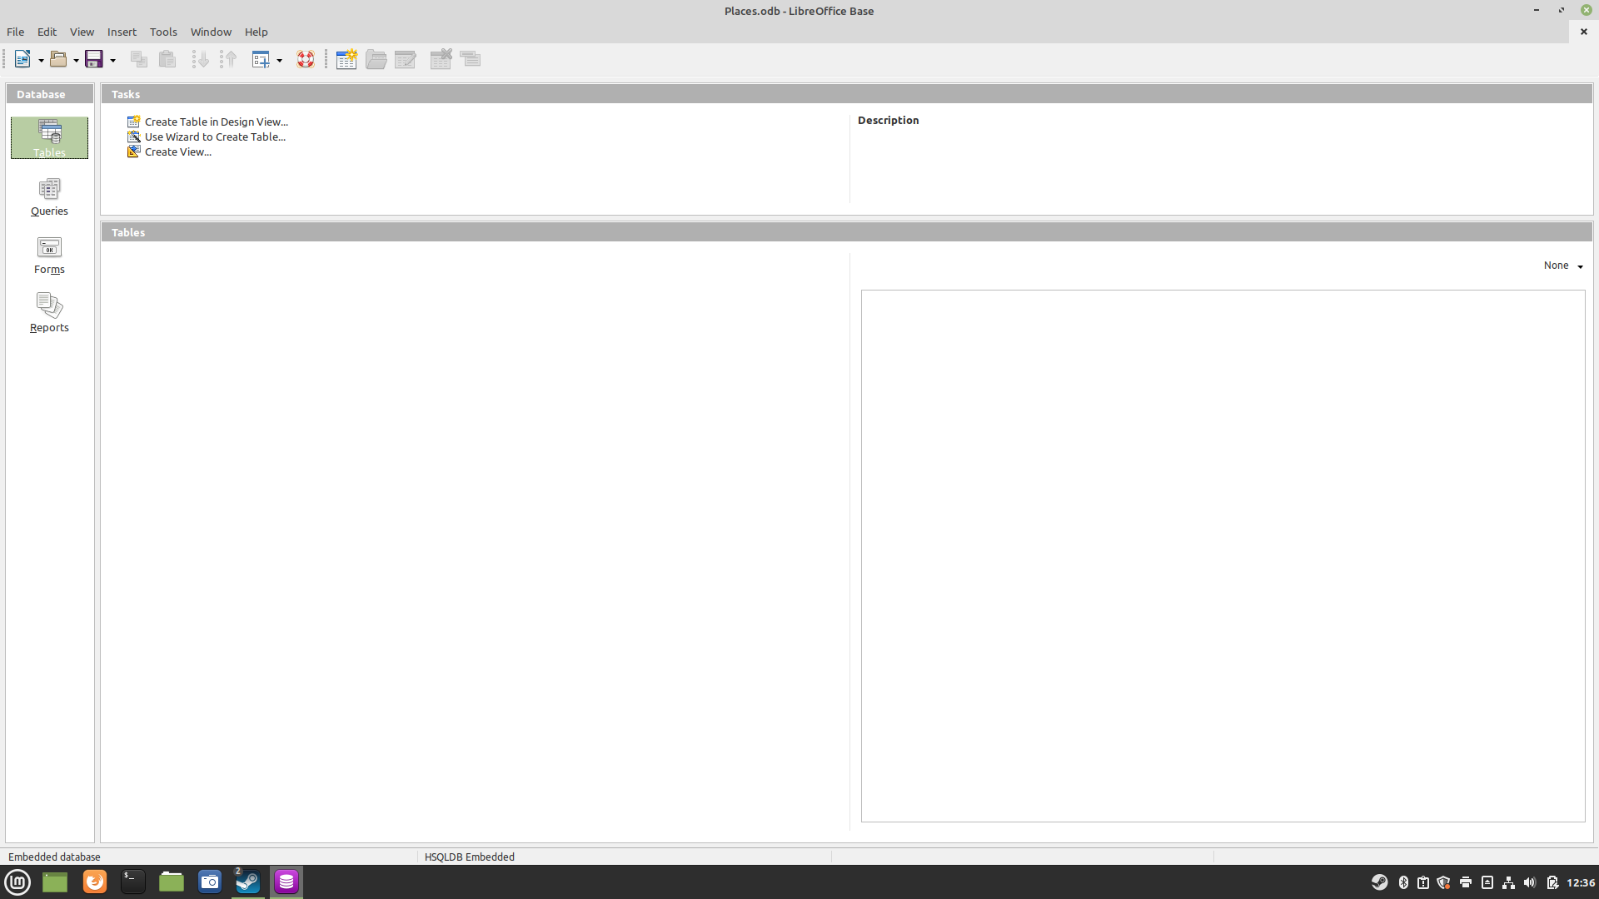
The Base environment contains four work areas: Tables, Queries, Forms, and Reports. Depending
on the work area selected, various tasks—creating new content or calling up existing elements—
may be carried out.
Base starts with the Form view, because forms are the elements most commonly used when
working with databases



