

Introduction to LibreOffice Base
Date Created October 2021
Reviewed
Version

Description
Course Notes from elearn.ellak.gr

All educational material is available at elearn.ellak.gr with open Creative Commons CC-BY-SA licenses that allow the reuse of the content.

Typographic Conventions
Style | Description | Example
Text Body  Liberation Serif 10 | Normal body text | This is normal text
Key (Light Teal 4) | Keyboard shortcut | Press Ctrl + c to copy object
sudo su | Commands that should be run by theuser | sudo apt update
menu | Menu Item | File > save to acess the save feature

Table of Contents
Typographic Conventions 2
What is a database? 4
Tables 4
Why use a database? 5
Relational databases 5
Introduction to Base 6
What is LibreOffice Base 6
Creating a database 6
Step 1 6
Step 2 7
Step 3 8
Base main window 8
Database Objects Types 8
Database Tasks 9
Database Objects List 9
Tables 10
Table properties 10
Table Name 10
Table fields 10
Field Data Types 11
Records 11
Primary keys 12
Creating a Table 12
Table Design View 13
Saving a table 14
Database Object Toolbar 15
Entering data 15
Queries 16
Creating a query 16
Query parameters 19
Running the query 19
20
Editing the Query 20
Forms 21
Creating forms 21
Step 1 22
Step 2 23
Step 3 24
Step 4 25
Step 5 26
Step 6 27
Using the Form 28
Navigating 28
Creating and modifying a record 29
Managing a form 30
Reports 31
Creating Reports 31
Step 1 31
Step 2 32
Step 3 33
Step 4 33
Step 5 34
Step 6 35
Managing a Report 36
Editing a Report 36
Assignment 37
Customers DataBase 37
Instructions 37
1. Create a Database 37
2. Create the Customers Table 37
3. Create table fields 37
4. Enter table data 37
5 Create the Query 38
6 Create the Form 38
7. Create the Reports 39
8. Edit the reports (optional) 39
9. Save and submit 39

LibreOffice Base is a database creation and management application. To understand Base, you must first understand databases.

What is a database?
A database is a collection of data that is stored in a computer system. Databases allow their users to enter, access, and analyze their data quickly and easily. Databases are everywhere. When you are searching for a book in the library computer or when you buy something from a store you use a database. Databases are everywhere on the web too. Articles, pages, videos, images or products you see on various websites are all stored in databases.
The easiest way to understand a database is to think of it as a collection of lists. Think about the library database we mentioned above: The database of a library contains a list with all the books and a list with all library members.
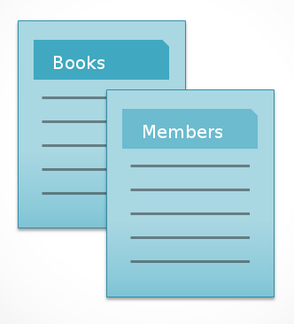

Tables
In databases those lists are called tables. LibreOffice Base and other Database Management Systems store all the data in the form of tables. A table contains all the data of a list with more detailed information. In the table below, the Books list in the library database example has been expanded to include other relevant information.
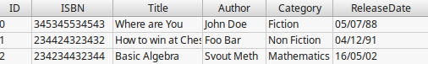

Why use a database?
If you can build tables in Calc, then why do you need a real database in the first place? Calc is a spreadsheet application and is mainly designed to store and analyse numerical data. Base is far stronger at handling non-numerical data, like names and descriptions. Non-numerical data plays a significant role in almost any database, and it's important to be able to sort and analyse it. Furthermore a database system like Base is optimized to handle large amount of data.

Relational databases
A database can have multiple tables that model the real world application. In our library database example if we want to keep track of the books that every member has loaned then we will add a third table called loans.
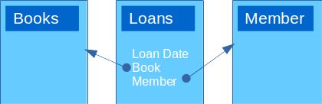

A database with tables that relate to each other is called a relational database. A relational database is able to understand how tables and the objects within them relate to one another.
In our example the Loans table instead of storing the book and member information it simply relates or points to the entry in the Books and Members Table. Relational databases help us eliminate data duplication and keep data integrity.
The fact that relational databases can handle information this way allows you to enter, search for, and analyze data in more than one table at a time. All of these things would be difficult to accomplish in Calc, but in Base even complicated tasks can be simplified and made fairly user friendly.

Introduction to Base

What is LibreOffice Base
LibreOffice Base is a database software, similar to Microsoft Access, which provides a graphical interface for working with databases. In addition, Base contains a version of it’s own database management system, Hyper-SQL DataBase (HSQLDB) that can be used to create small, self contained, single user database applications. Furthermore Base can connect to a variety of external database systems such as MySQL or simply to a file data source (spreadsheet or text file). LibreOffice Base is just the front end allowing us to tie into the actual database.

Creating a database
To create a database start LibreOffice Base from your system application start menu or use LibreOffice Start Center.

Step 1
Every time you start Base the Database Wizard appears.
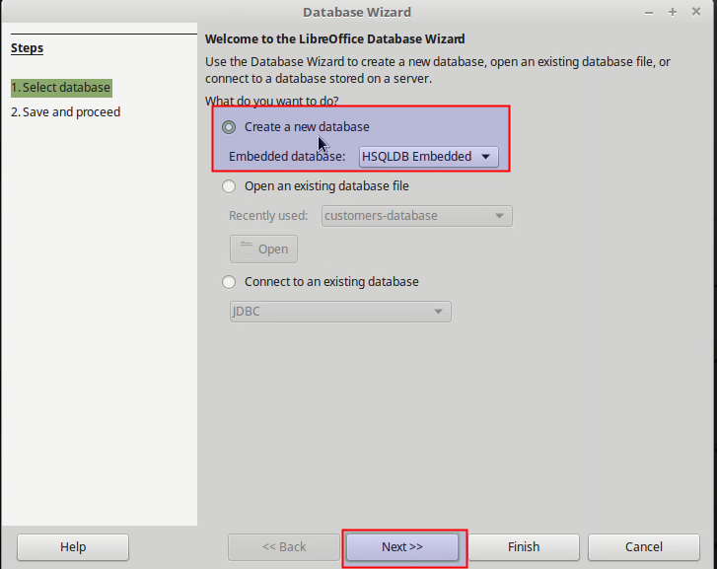
In the first step of the Database wizard you have the following options:
- Create a new database
- Open Existing database stored on your computer.
- Connect to an existing database created with other applications or database engines. For example it can connect to an SQL database.
Select the first option to create a new database using the embedded database system HSQLDB.

Step 2
In the next step leave the default options. Registering a database in LibreOffice means that other components can have access to the data. For example you can access data from a Calc spreadsheet or from a Writer document when using the Mail Merge function.
Make sure the option Open the database for editing is selected and click Finish.
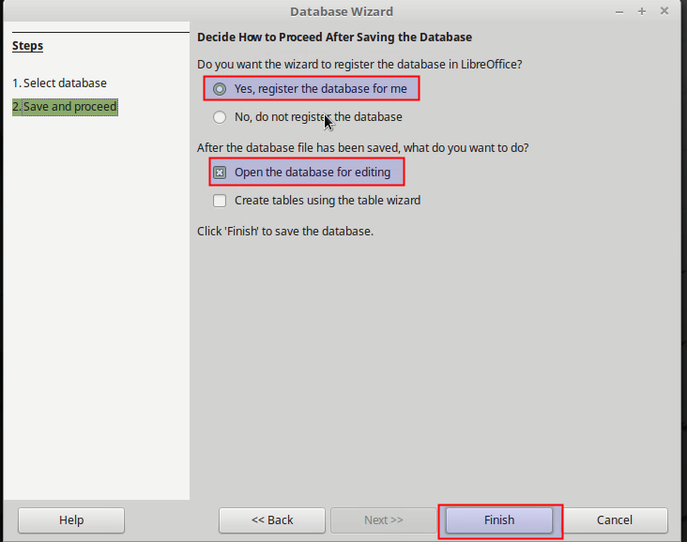

Step 3
Before opening the database for editing, Base will ask you to name and save your new database. Database files in Open Document Format are stored with the *.odb extension. This file format is actually a container of all elements of the database, including forms, reports, tables, and the data itself.

Base main window
Base main window besides the Title Bar, Main menu and Toolbars, consists of three window panes: Database Object types, Database Objects list and Tasks.
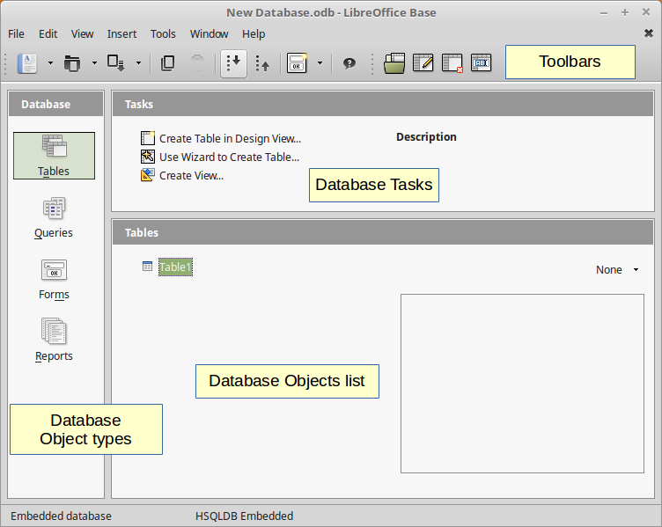

Database Objects Types
Databases in LibreOffice Base are composed of four objects:
- Tables
- Queries
- Forms
- Reports
Together, these objects allow you to enter, store, analyze, and compile data however you want. We will explain these objects in detail in the next lessons.

Database Tasks
For each database object type, the Tasks window lists the available tasks along with a description. For example the tasks for Tables include to Create a Table in Design View or Use Wizard to Create Table.

Database Objects List
All the objects that we create for a given type are listed in this Window. From there you can open, edit, rename or delete an object.

Tables
A database is made up of several components, of which the table is most significant. A table is a collection of related data held in a structured format within a database. All data in a database is stored in one or more tables which puts tables at the heart of any database. A table to store a list of books in a library is shown in the image below.
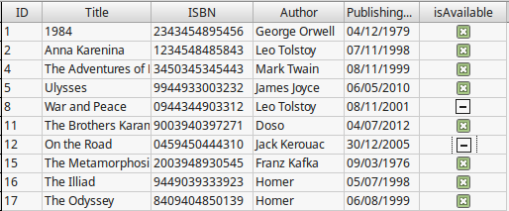

Table properties

Table Name
The table name describes the type of data stored. For example a table that stores information about books in a library would simple be named Books. It’s a good practice to name the table using the plural form (Books instead of Book). Tables are organized into vertical columns and horizontal rows.

Table fields
Every book in our library has some common attributes or properties. For example the book title, author and ISBN number. These attributes are called the table fields and represent the columns of our table.

Field Data Types
Each field in a table must have a field name and a data type. The data type depends on the information this field will store. The most basic field types are listed below:
- Text. This is the most common data type. It's used for storing text information such as name, addresses, descriptions etc.
- Integer. For integer numbers. For example 20 232 1003.
- Decimal. Numbers with decimal digits or real numbers. For example 0.6 34.34234 3.134545.
- Date or Time. For storing date and time information. For example 19/02/2017 18:22:10.
- Boolean. This type has can can have the "True" or "False" value.

Records
A record is a unit of information inside a table. For example, to store a particular book in our Books Table we insert a new record (or row) and fill all the fields with data. Notice how each record spans across all table fields.

Primary keys
In the world of databases, the primary key of a relational table uniquely identifies each record in the table. Databases use keys to compare, sort, and store records, and to create relationships between records. In the books Table the primary key is the ID field and for every book the ID is unique meaning that two ore more books can not have the same ID. A table in Base must always contain a primary key.

Creating a Table
You can create a Table in Base using either the Design View or the Create Table Wizard. It is recommended to use the Design View to better understand the table concept in Databases. To create a table:
- Select the table object type
- Create Table in Design View from the Tasks window.

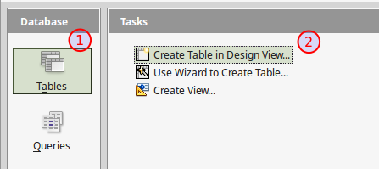

Table Design View
In Table Design View you create a table by entering all the table fields information (field name, data type and description). For each field you can also specify some Field Properties.
Always enter first the primary key for your table. The primary key must be of type Integer and have the AutoValue property enabled. This means that Base will fill this value for us whenever we create a record. This is a good practice because we avoid entering duplicate primary keys in our table.

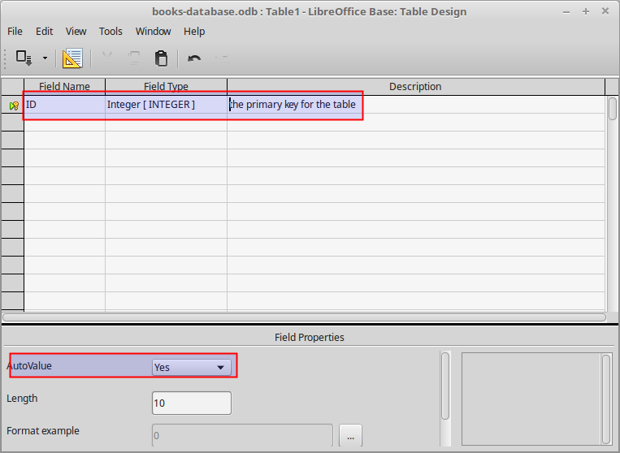

Next enter the remaining fields of your table
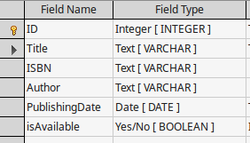
For each field you can specify some properties
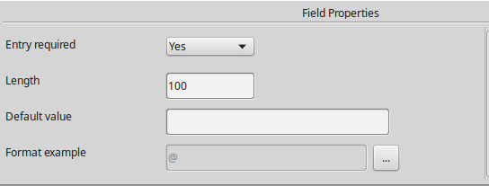
- Entry required. If set to Yes a value must always be filled a record for this field.
- Length. The length can be set to a maximum value to to constrain the size of a numerical or text field.
- Default value. A field can have a default value
- Format. For numerical, date and time values you can set the display format of the value.

Saving a table
To save your table click on the save button and give the table a name. The table now appears in the Tables list.

Database Object Toolbar
Once you create any database object if you select it from the Objects List the Database Objects toolbar is activated. Using the toolbar you can open, edit, delete or rename the object.
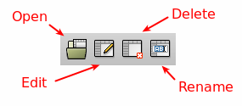
Open. Opens the Table to enter data.
- Edit. Opens the Table Design View to edit table fields and properties
- Delete. Deletes the tabla
- Rename. Renames the table

Entering data
To start entering data in a Table, select the table and click on the Open Button , or double click on the table in Objects List. When opening a table this way the Table Data View window appears.
In Table Data View you can enter new records by typing the values in each row. If you switch the Edit Mode to Off then you can only view the data. In this window you can also sort and filter the table data. When done click the Save button to save your changes.
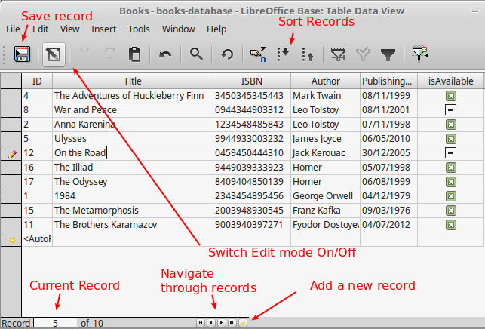

Queries
The real power of a relational database lies in its ability to quickly retrieve and analyze your data by running a query. Queries allow you to pull information from one or more tables based on a set of search conditions you define. For example you could ask question such as: what are the available books in my library?, who bought this product in the last month?

Creating a query
LibreOffice Base allow us to design, execute and store a query. You can create a query with one of the following ways:
- Create a Query in Design View. This method allows us to design a query from scratch. Use this method because it will help you undestand the comcept of queries.
- Use Wizard to Create a Query. The wizard will guide you to create a query from a selected table.
- Create a Query in SQL View. SQL stands for Structured Query Language. SQL is the standard language for relational database management systems. If you want to really dive into databases you should learn the SQL language. This lesson however does not cover SQL.
To create a query select the Queries object from Database objects types and click on the Create Query in Design View Task.
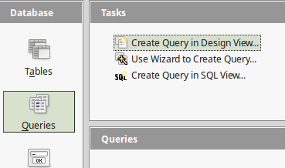

A query needs at least one table or another query where it can retrieve the data. Select the Books table from the list to add it to the query.
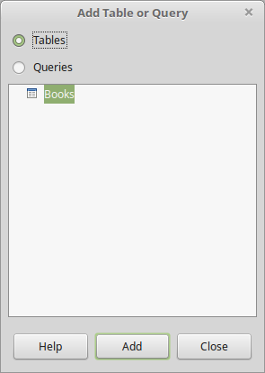
Once you add the table close the Add Table or Query window. Now the Query Design window appears. The upper part of this window displays the data sources where the query retrieves data from. In the bottom part we set the query parameters.
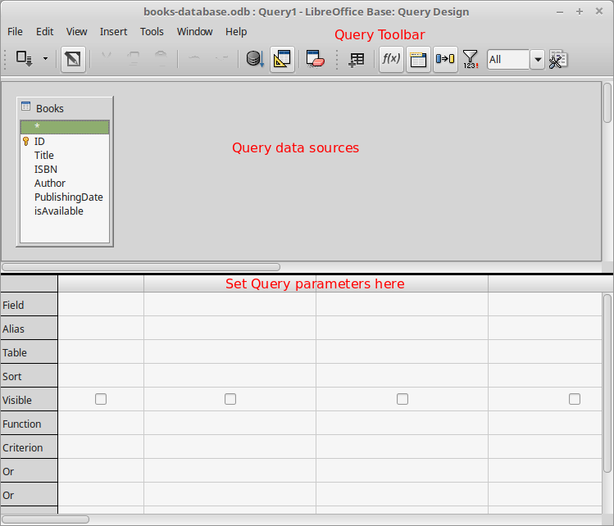

Query parameters
Let’s now for example design a query that will ask the question: What books are available in my library? Show me the title and author of these books. To design a query we must specify it's parameters:
- Fields. The table fields to show in query results or use in the query's criteria.
- Sorting. You can specify sorting for the results by one or more fields.
- Criteria. This is where we actually set the conditions for the query. We can set multiple criteria in a query.
- Visible. If enabled the field will be visible in query results.
For our query we set the following query parameters:
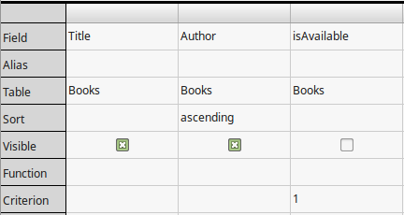
Fields: Title, Author, isAvailable.
Sort: Ascending by Author.
Visible: Title, Author.
Criterion. isAvailable = 1. For boolean types the value "1" means "True" and "0" means "False".

Running the query
To run the query and display the results click on the Run Query button on the toolbar. The query results are now displayed in the Query window. Now click the save button to save the query with the name AvailableBooks.

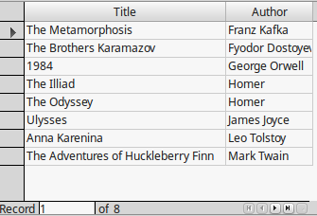

Editing the Query
When a query is saved, is listed in the Queries window. You can now open, edit, delete or rename the query using the Query toolbar buttons on top of the main Base window.
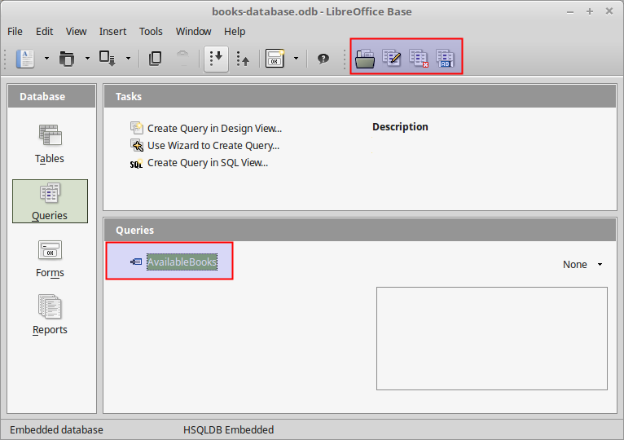

Forms
While you can always enter data directly into database tables, you might find it easier and more user friendly to use forms. Forms ensure you're entering the right data in the right location and format. This can help keep your database accurate and consistent.
With forms, database designers can control exactly how users are able to interact with the database. They can even set restrictions on individual form components to ensure all of the needed data is entered and that it's all entered in a valid format. This is useful because keeping data consistent and organized is essential for an accurate and powerful database.

Creating forms
In LibreOffice Base you can create a Form using:
- Create a Form in Design View. Using this method you create a form from scratch, having complete control of the form design. This option is suitable for more advanced users.
- Use Wizard to Create Form. The Wizard guides you through a step by step process to create the form. Unlike tables and queries, creating a form from scratch is difficult for beginners. Therefore this is the recommended method to create a form.
Select Use Wizard to Create Form form the Tasks window to start creating a form.
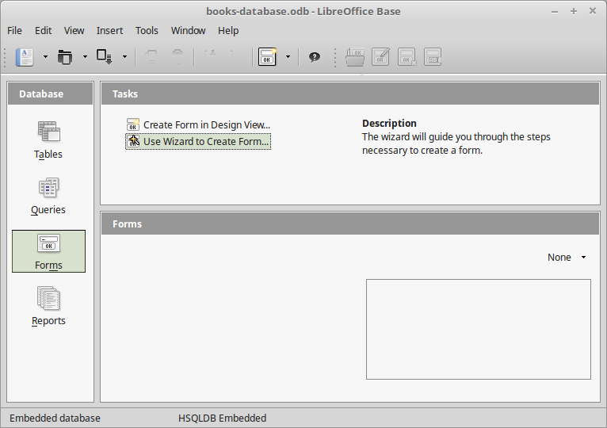

Step 1
The Form Wizard window appears. In this step you select the fields that the form must contain. Select all the fields from table Books except the ID. The ID field is filled automatically every time we create a new record.
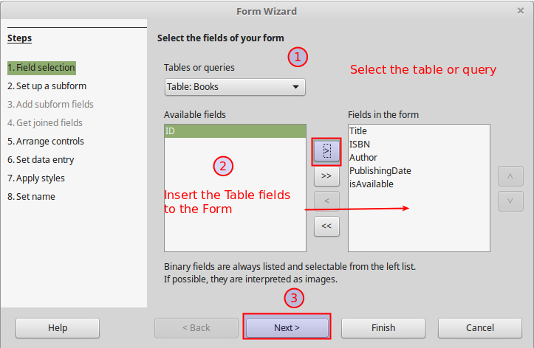

Step 2
In relational databases a table can connect to another table and similarly a form can contain a subform. Skip this step now because our database is flat and does not have any relations.
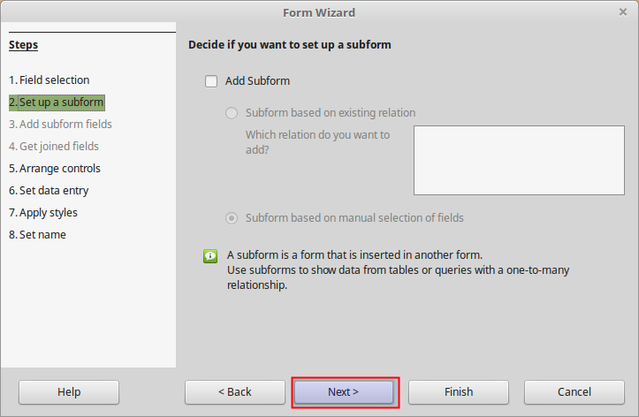

Step 3
In this step we choose the form layout or arrangement. Click on all available options to preview the result. For this form choose the Columnar - Labels Left layout.
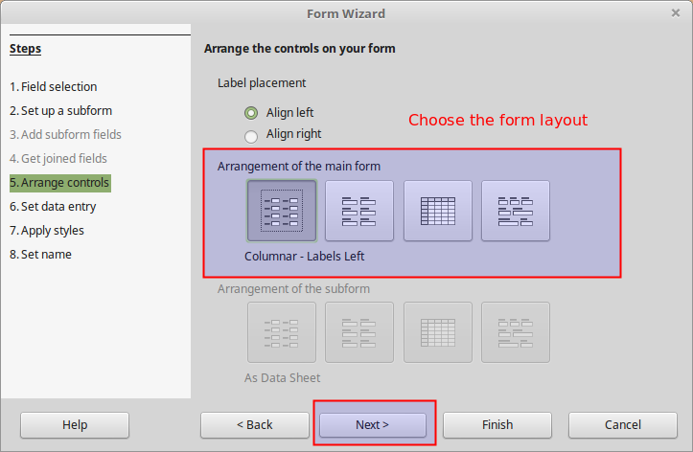

Step 4
In this step we specify the data entry mode. You can create for example a form that the user can only add records but not modify existing ones. In our example we will leave the default options so that the form user has full rights.
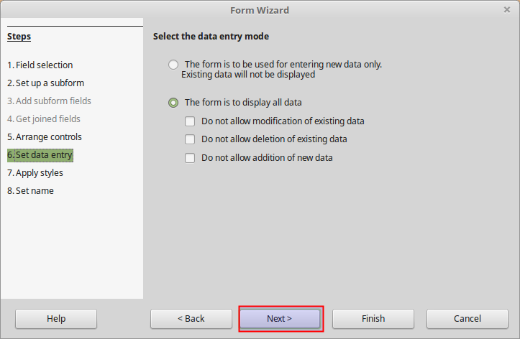

Step 5
In this step you can quickly style the form using one of the predefined styles. Choose a style (Bright Blue for example) and click Next.
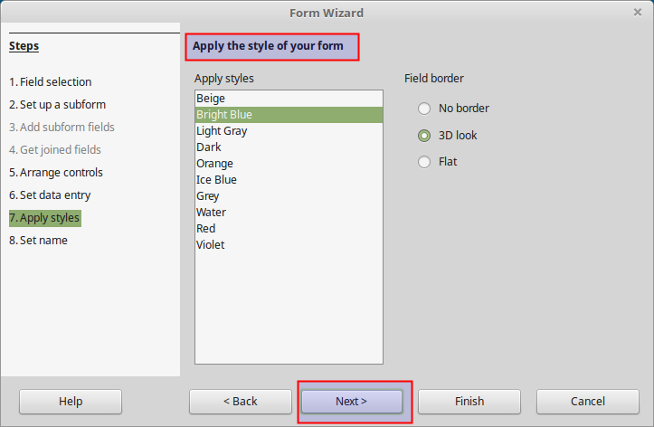

Step 6
In this step we set the name of the form and how we want to proceed after creating the form. Name the form Books or BooksForm and Choose Work with the form.
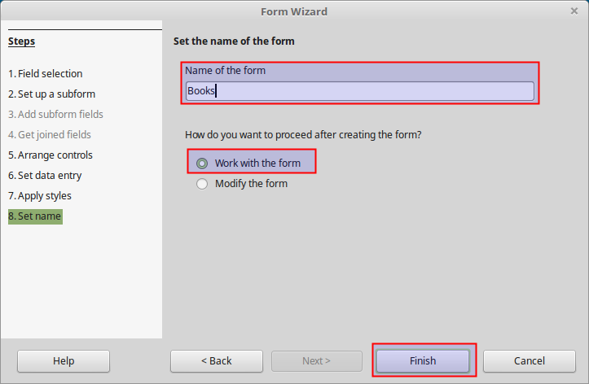

Using the Form

Navigating
When we open the Form it displays each record according to the chosen layout. Using the navigation toolbar on the bottom we can navigate to each record of the table. The toolbar on the bottom displays also the current record.
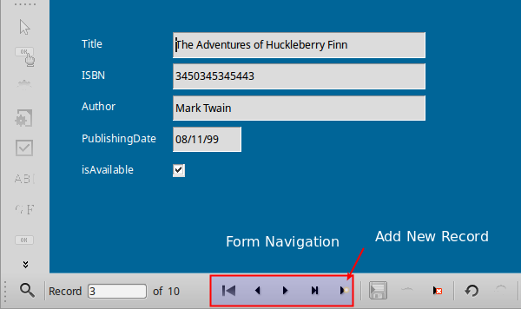

Creating and modifying a record
To add a record click on the Add New Record button on the navigation toolbar and fill in the form fields. To modify or update an existing record simply edit one or more field values. In both cases you must save your changes by pressing the Save Record button .
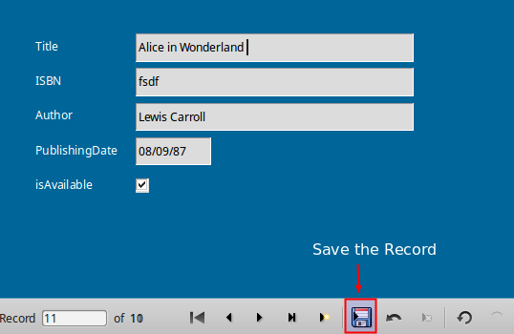

Managing a form
To manage a form click on the Forms object type in Database pane and select the form from the Forms pane. Use the Form toolbar to Open, Edit, Delete or Rename a form.
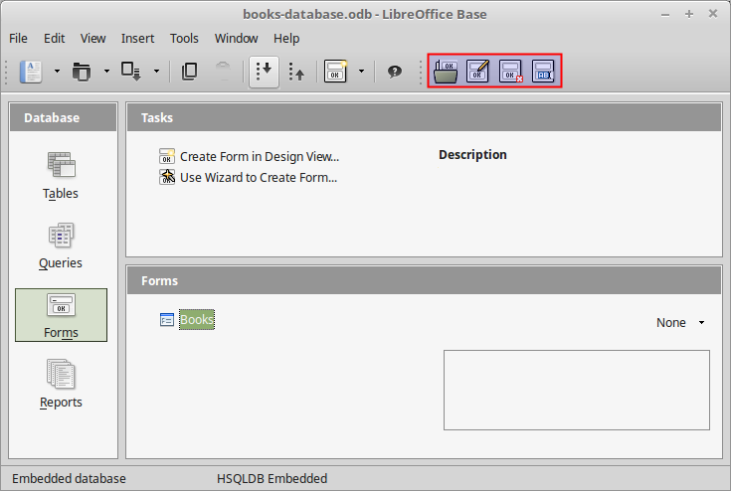

Reports
Reports give you the ability to present information from your database in an easy-to-read, visually appealing printable format. For example, you can create a simple report of phone numbers for all your contacts, or a summary report on the total sales across different regions and time periods. Base makes it easy to create and customize a report using data from any query or table in your database.

Creating Reports
In LibreOffice Base you can create a Report using
- Create a Report in Design View. Create a report from scratch.
- Use Wizard to Create Report. The Wizard guides you through a step by step process to create the report. Unlike tables and queries, creating a report from scratch can be difficult for beginners. Therefore this is the recommended method for to quickly and easily create a report.
Select the Use Wizard to Create Report. The Wizard opens a dialog window. In the following example we will generate a report that displays all book's title, author and publishing date. The results will be grouped by author.
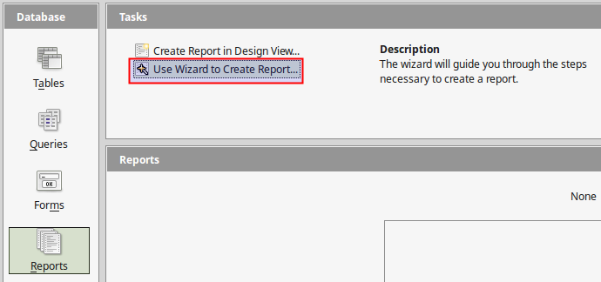

Step 1
In this step you select the Table Fields that you want the report to contain. In this example we select the Title, Author and PublishingDate fields.
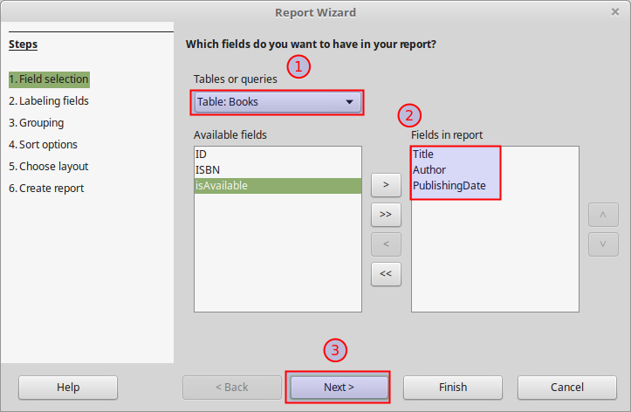

Step 2
The report generates a label for each field. By default Base chooses the field name for the label name. In our example we change the "PublishingDate" field to "Publishing Date".
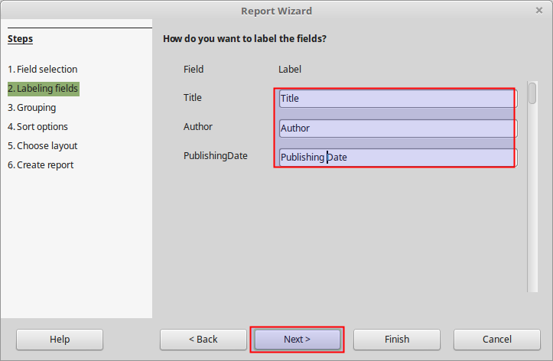

Step 3
A report can group the results by one ore more fields. In our example we choose to group the results by Author.
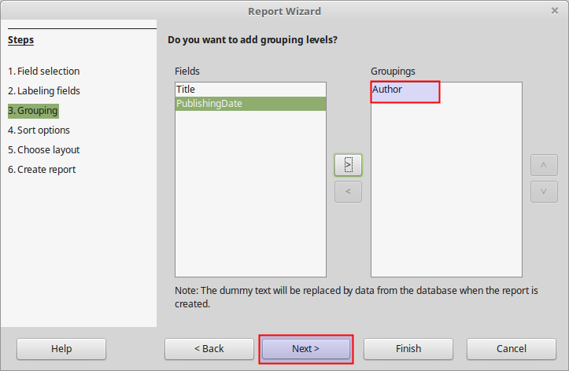

Step 4
As with queries, the results in reports can be sorted. By default results are sorted by the group field (Author). You can specify more levels of sorting. Leave the default values.
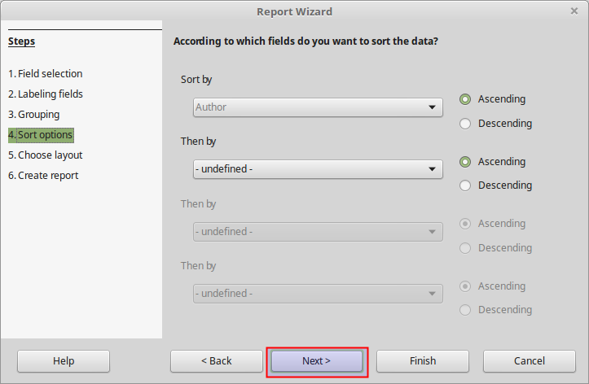

Step 5
In this step we choose the Layout for the data and the headers and footers of the report. Click on the available options to preview each layout.
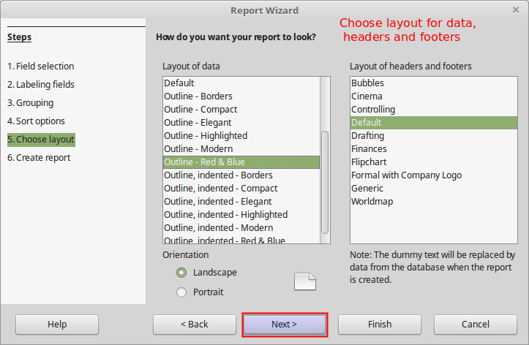

Step 6
Here we specify the title and the type of the report. A dynamic report generates data from the current table data. This means that if we update data on the table that feeds the report, the report will change accordingly.
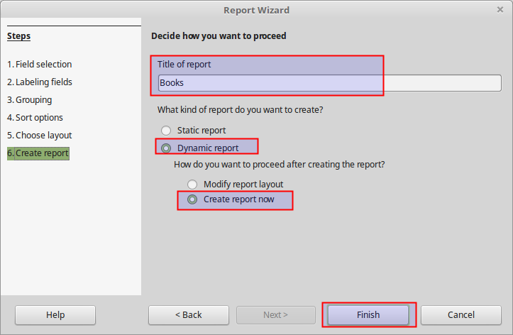
When you finish the wizard the report will be created and opened. The report is text document and therefore it opens using the Writer component of LibreOffice.
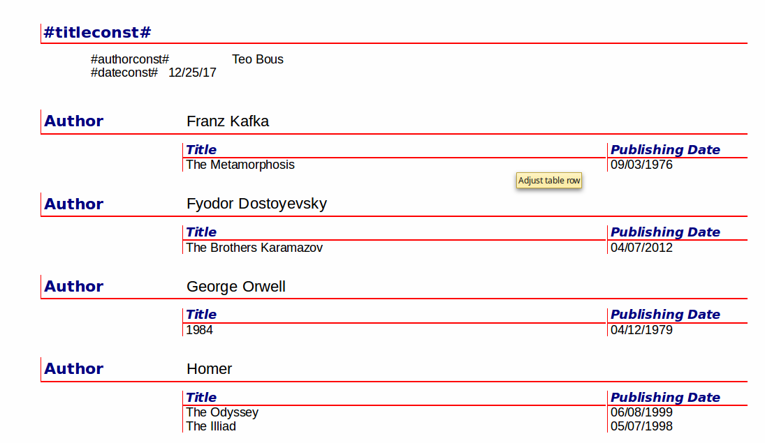

Managing a Report
To manage a Report first select the Reports Object from the Database Objects Pane and then select the report from the Reports List. Use the Reports toolbar to Open, Edit, Delete or Rename a Report.
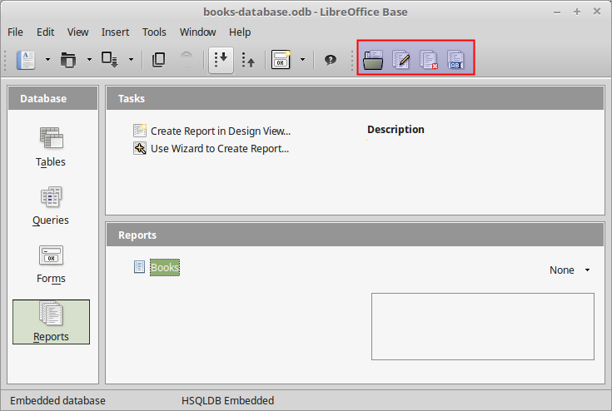

Editing a Report
A Report is basically a Writer document that acquires data from Base. Therefore you can edit a report like any other Writer Document. For example you can change the alignment of the Publishing Date column. When you edit a report you must save it using the Save Button from the Standard toolbar.
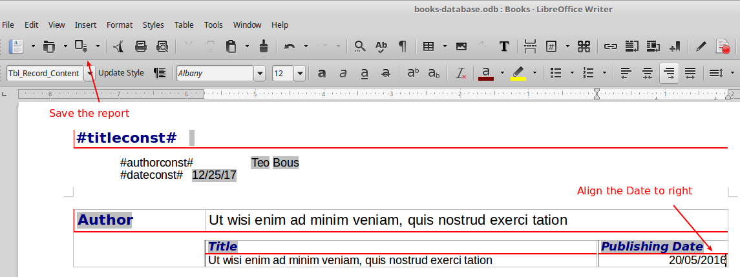

Assignment

Customers DataBase
In this project you will create a simple database application for a small business. The Database must contain the following objects:
- A Table holding customer information (name, address, etc)
- A Query that will return a list with all active customers full name and phone, sorted by last name.
- A Form for creating, reading, updating and deleting customer records
- A Report with the active customers
- A Report with customers info and credit limit grouped by city

Instructions

1. Create a Database
Create a new Database and with the name customers-database

2. Create the Customers Table
Create a Table in Design View with the name Customers. This table with hold the customer information.

3. Create table fields
The Field Name and Field Type are listed below
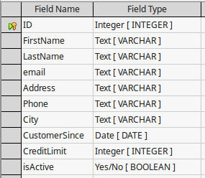
Primary Key. The ID field is the primary key of the Table and must have the AutoValue option to YES.

4. Enter table data
Open the customers table and enter at least 10 records
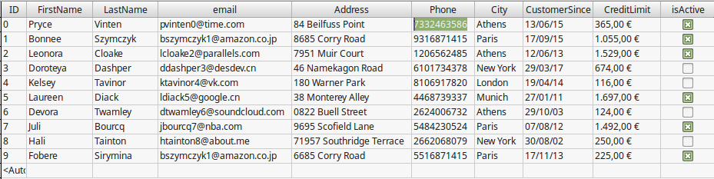

5 Create the Query
Create a query named Active Customers that will display all the active customers. The required query parameters are shown below:
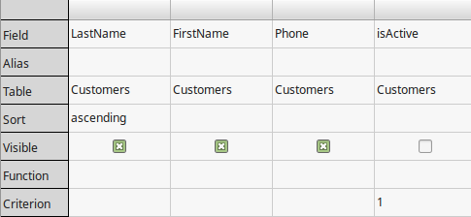

6 Create the Form
Create a Form named Customers using the Wizard. The form must display all fields from Customers table except the ID field. You can choose any of the predefined layouts. A form example is shown below.
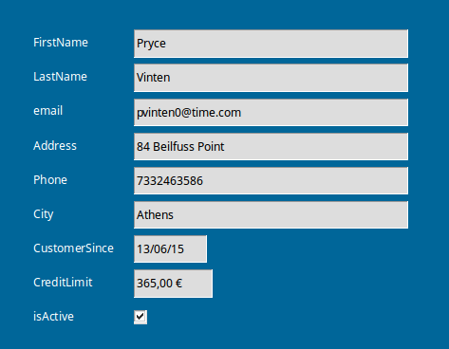

7. Create the Reports
Using the Reports Wizard create two Reports:
- Active Customers. A report that will display the active customers. This report will have as data source the Active Customers Query
- Customers by City and Credit Limit. A report that will display customers First Name, Last Name and Credit Limit. The Report must be grouped by City and sorted by Credit Limit.
In the attached pdf files you can see examples of the reports.

8. Edit the reports (optional)
Add the company logo provided to the header of each report.

9. Save and submit
Save the database using the default odb format and Submit

