

Changing IP address of Pi

Date Created
Reviewed
Version

Description
Changing IP address of your Raspberry Pi from Dynamic to a Static ip address

If your Raspberry Pi is configured to used a dynamic ip address and you would like to assign it a static address so that u can use it as a home server, use the following steps.
First of all, you need to identify the Raspberry Pis existing IP address. If you have access to the console, it is easy to do, if not you shall require to run some kind of network scan or check the DHCP lease for identifying the address. Follow this link for identifying the ip address of Raspberry Pi using network scan.
You shall need to identify your devices
- IP address
- Netmask/Network address
- Default gateway
- DNS
If you have console access you can examine the IP address using the following command ( this shall work both over ssh using putty and directly from the console)
ip addr
The output will be something similar to this, follow the bold section
2: eth0: <BROADCAST,MULTICAST,UP,LOWER_UP> mtu 1500 qdisc pfifo_fast state UP group default qlen 1000
link/ether b8:27:eb:25:43:23 brd ff:ff:ff:ff:ff:ff
inet 192.168.1.7/24 brd 192.168.1.255 scope global eth0
valid_lft forever preferred_lft forever
inet6 fe80::88a5:bc2e:fd52:87fd/64 scope link
valid_lft forever preferred_lft forever
This indicates the ip address of the RaspberryPi device is 192.168.1.7
The netmask is /24 or 255.255.255.0
Which makes the network address of 192.168.1.0
To find out the default gateway run
route -n
You shall see a similer output of
pi@raspberrypi ~ $ route -n
Kernel IP routing table
Destination Gateway Genmask Flags Metric Ref Use Iface
0.0.0.0 192.168.1.1 0.0.0.0 UG 202 0 0 eth0
192.168.1.0 0.0.0.0 255.255.255.0 U 202 0 0 eth0
Default gateway 192.168.1.1
To find out the dns addrss assigned by the dhcp server
cat /etc/resolv.conf
pi@raspberrypi ~ $ cat /etc/resolv.conf
# Generated by resolvconf
nameserver 192.168.1.1
DNS server/Name server is 192.168.1.1
Now that we have the information we need to change the Raspberry Pi configuration from dynamic to static we can start changing the configuration. Before we make any changes, it is wise to make a backup of the file you intend to change
sudo cp /etc/network/interfaces /etc/network/interfaces.orig
Now edit the file
sudo nano /etc/network/interfaces
You shall see something like this
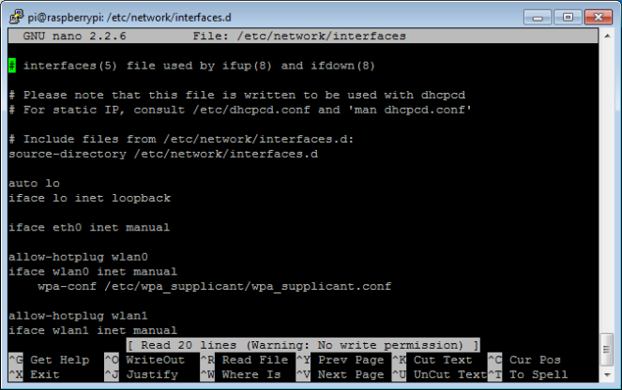
Remove the line that reads
iface eth0 inet manual
Add the following
allow-hotplug eth0
iface eth0 inet static
address 192.168.1.201
netmask 255.255.255.0
gateway 192.168.1.1
dns-nameservers 192.168.1.1
Now to check run
sudo service networking restart
Your device ip address is static.
Run
ifconfig
route -n
cat /etc/resolve.conf
Try pinging other hosts check connectivity. Hope you find this tutorial useful.

