

An Introduction to Code Clubs
Date Created June 2022
Reviewed July 2022
Version 1.1

Description
First in a series of articles developing the idea and implementation of Code Clubs in Zambia
for more information go to codeclub.org
For help Contact: howard@giakonda.org.uk

Code Club? What is a code club?
A Code Club is a safe place for children where they can explore how computers work, and how to make them do things.
Coding is the name given to the art of programming a computer to complete some sort of task. The program be as simple as adding a couple of numbers or as complex as monitoring a weather station.
Whatever you want a computer to do you can start your journey by learning how to program in a Code Club.
Code Clubs have been established in Schools, Libraries and Youth Clubs.
So what do you need to start your code club?
All you need is a keen teacher, a few computers, willing learners and maybe some outside support.
One type of computer that can be fun to program is the Raspberry Pi computer. I use this computer for four reasons:
1. Their power consumption is low which is very important in rural schools where electricity is often in short supply.
2. They can be used for the usual office applications such as word-processing. and most importantly for physical computing that is getting the computer to monitor and control things.
3, The Raspberry Pi has two very useful programs installed that will help with programming (coding if you prefer)
a) Scratch A visual programming language for younger children.
b) Python An easy to learn yet powerful programming language.
4. The Raspberry Pi family of computers are very cost effective. Costing from as little as $8
In the following articles we will look at the things we can do with learners in our code club.
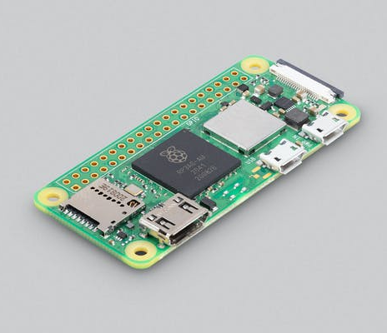
We will use the Python language on the Raspberry Pi to explore the art of programming. You can use python on the internet and on other computers if you prefer.

This is the Raspberry Pi Zero 2 W
A tiny, tiny $15 computer

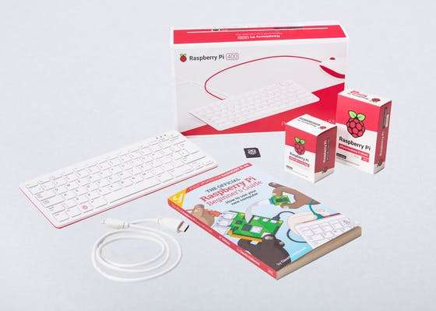

This is the Raspberry Pi 400 Desktop Kit
A full desktop computer kit - just connect to HDMI display(s) $150

